ASSIGNMENT-4

Creation of EBS Volumes i) Mount and persist the volumes ii) Create the snapshot the volumes iii)Get the volumes from snapshot iii) Attach the volumes to other region NOTE:- once snapshot created will the file will reflect in other region

Launch a instance with named (58e-snapshot) selecting Amazon linux (AMI) and t2.micro as storage and CPU and create a new key pair

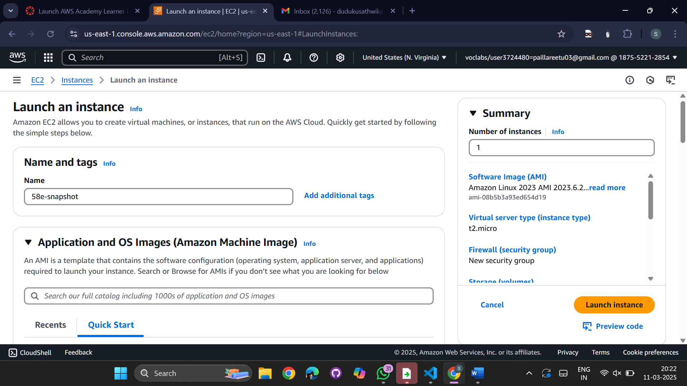  
Select the instance from Instances

Go to the left panel -> Elastic Block Storage -> Volumes

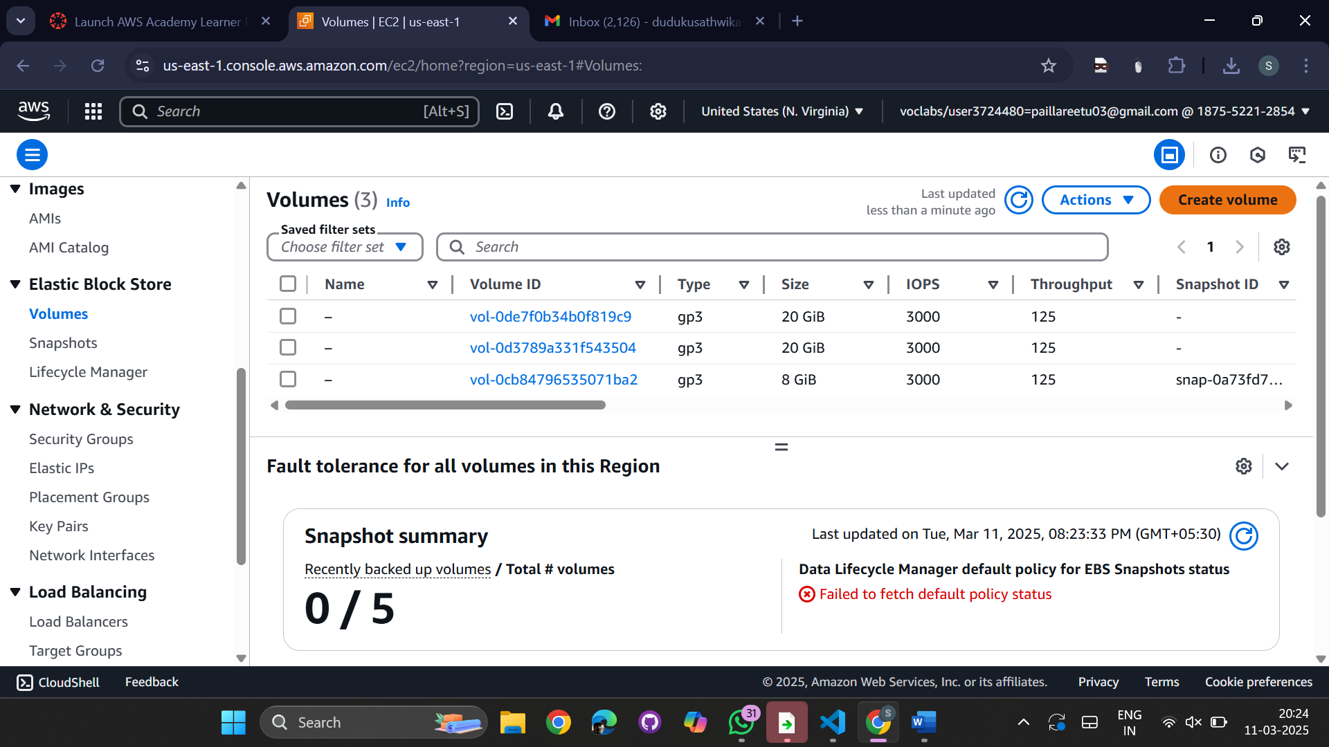

Create the volume with size 35 (GiB)  
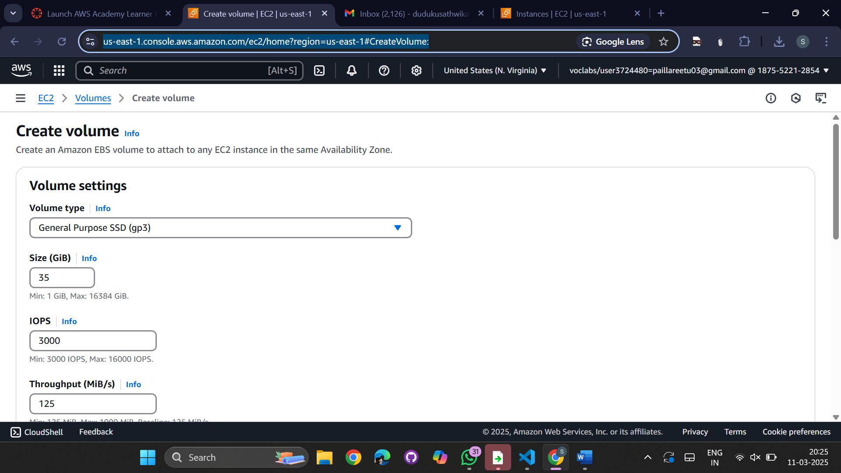

Region->us-east-1c-> create volume  
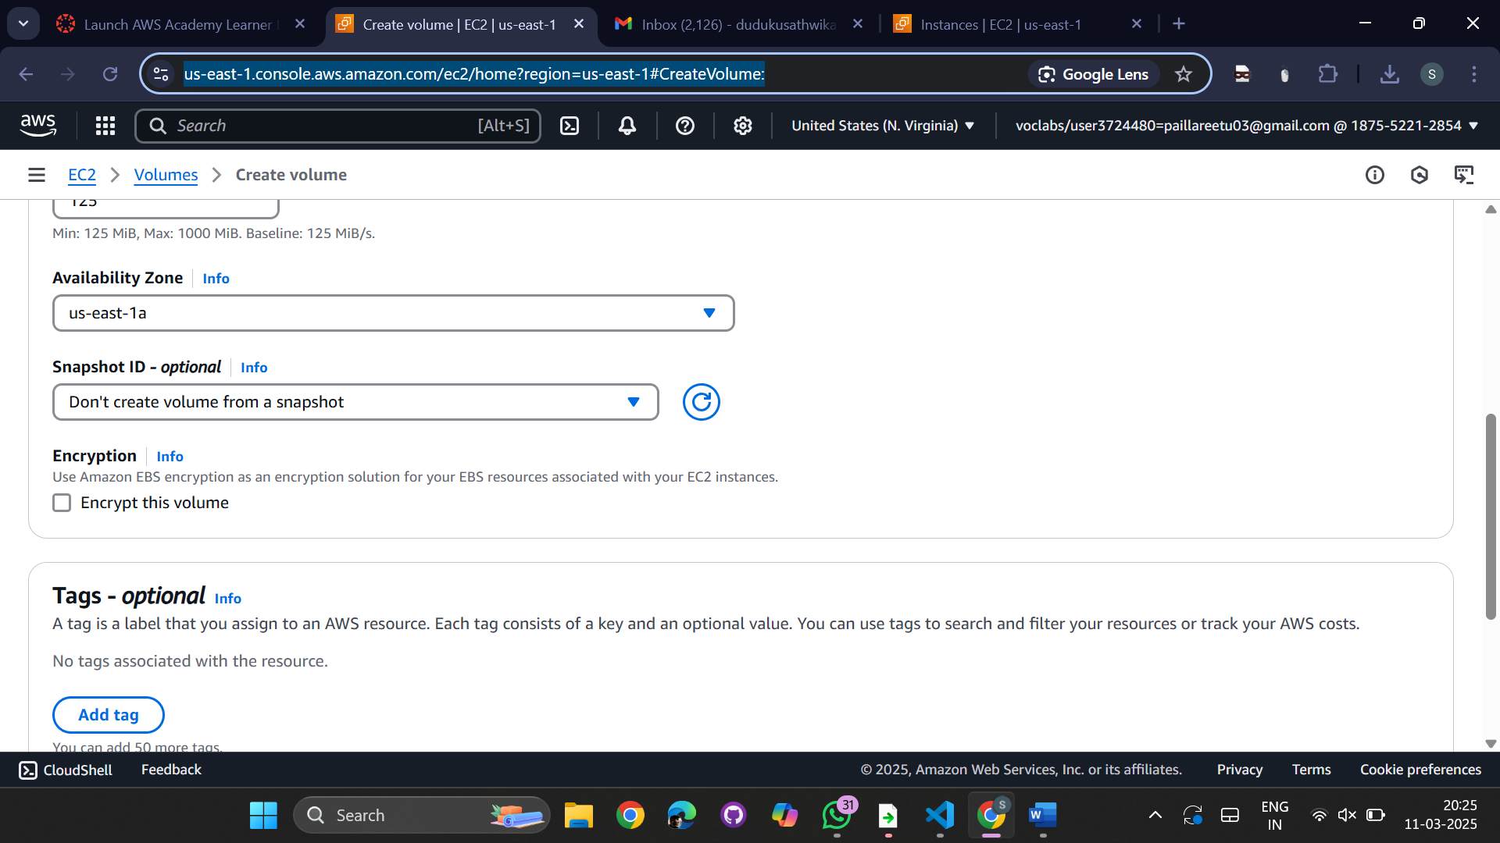

Select the volume created

Go to actions-> Attach volume  
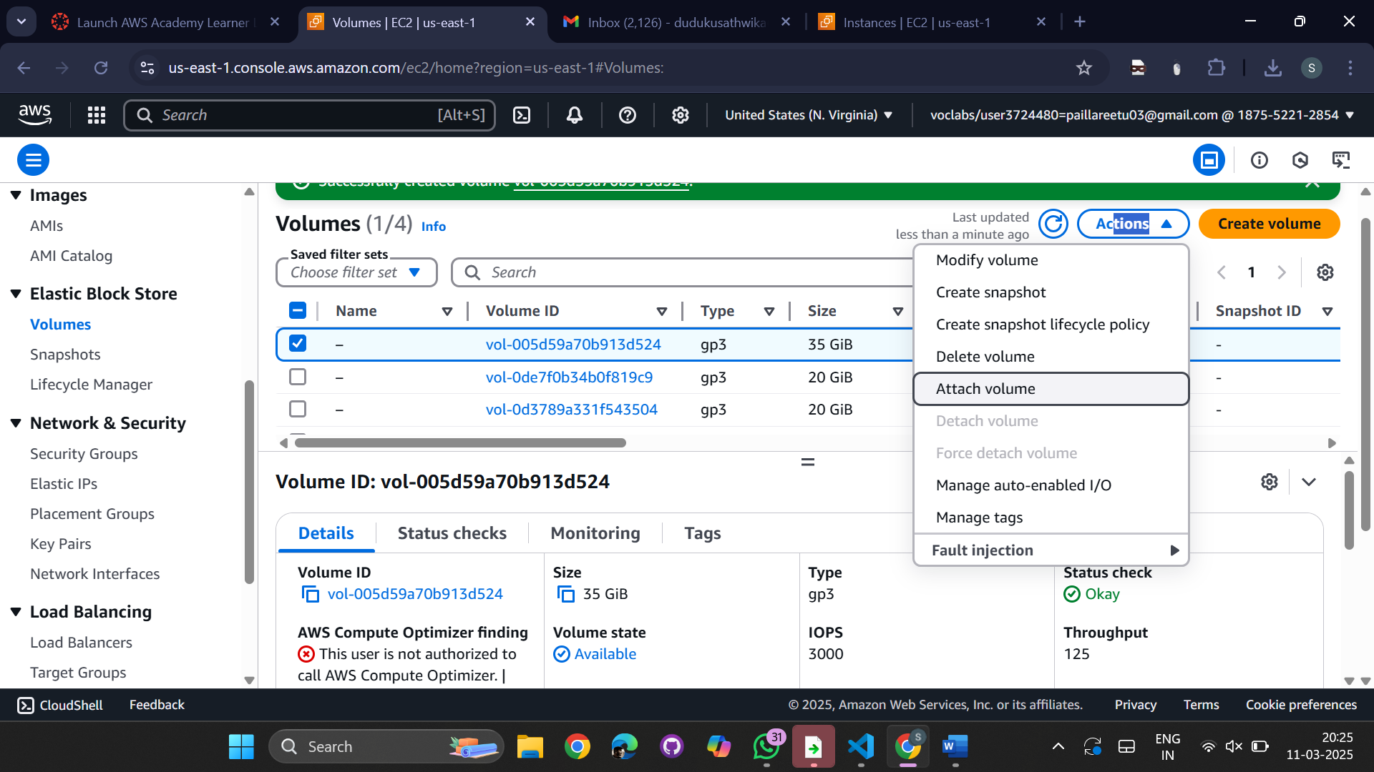  
Select the Instance and device name as dev/sdb -> attach Volume

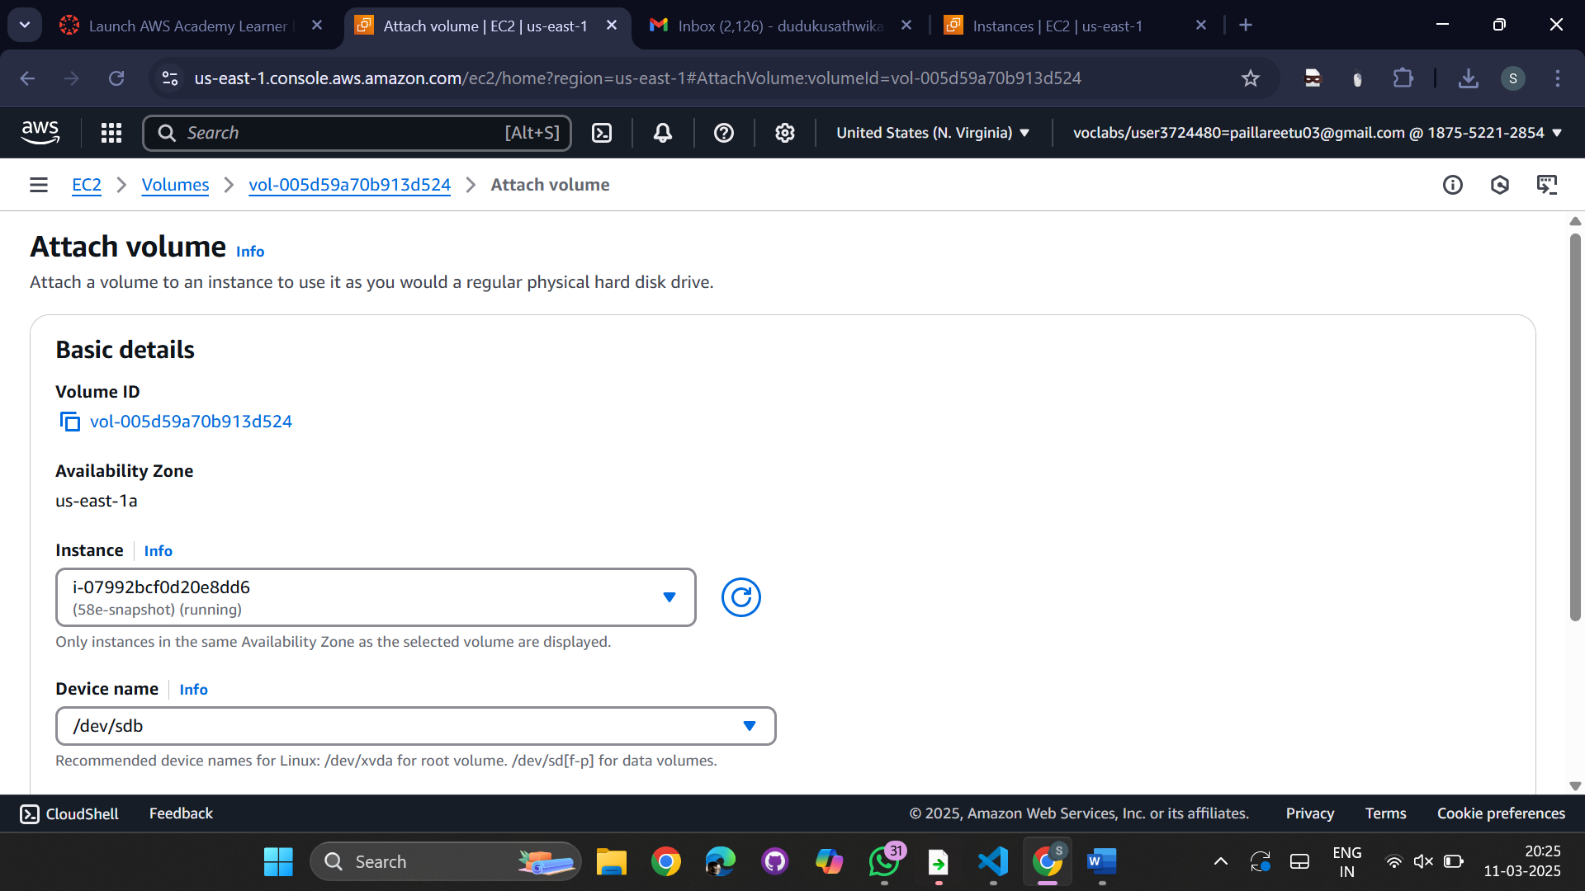

Go to instances -> Connect (EC2)

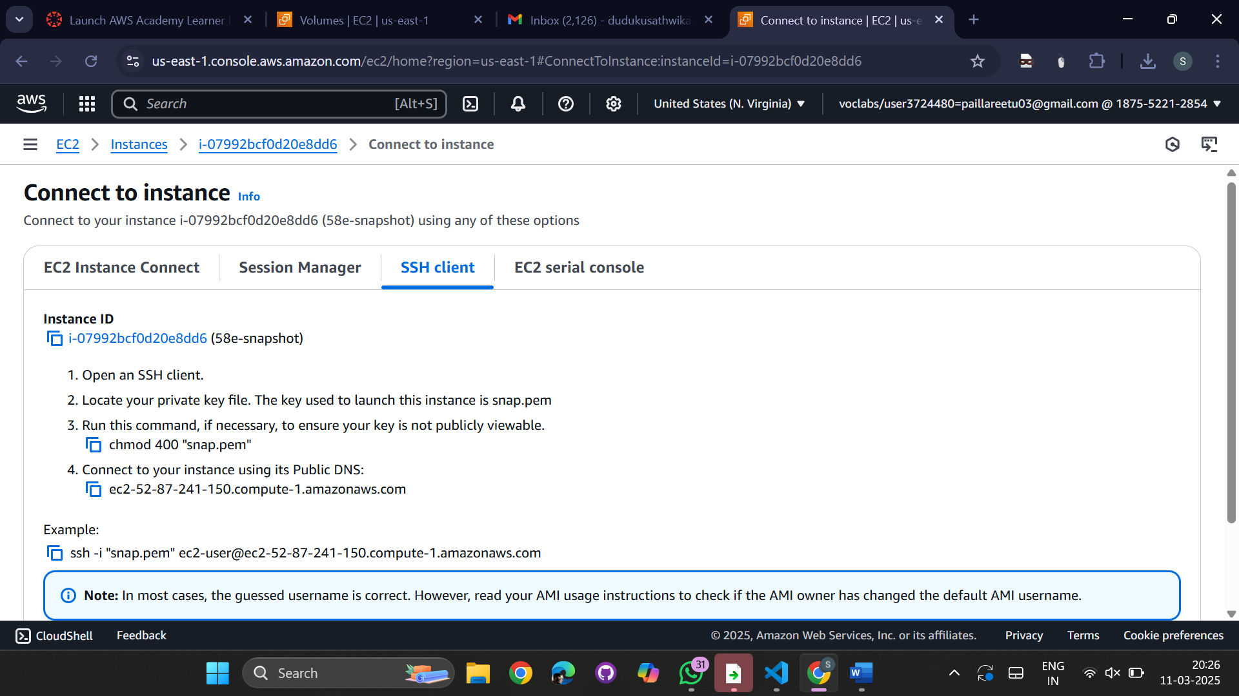

Execute the commands

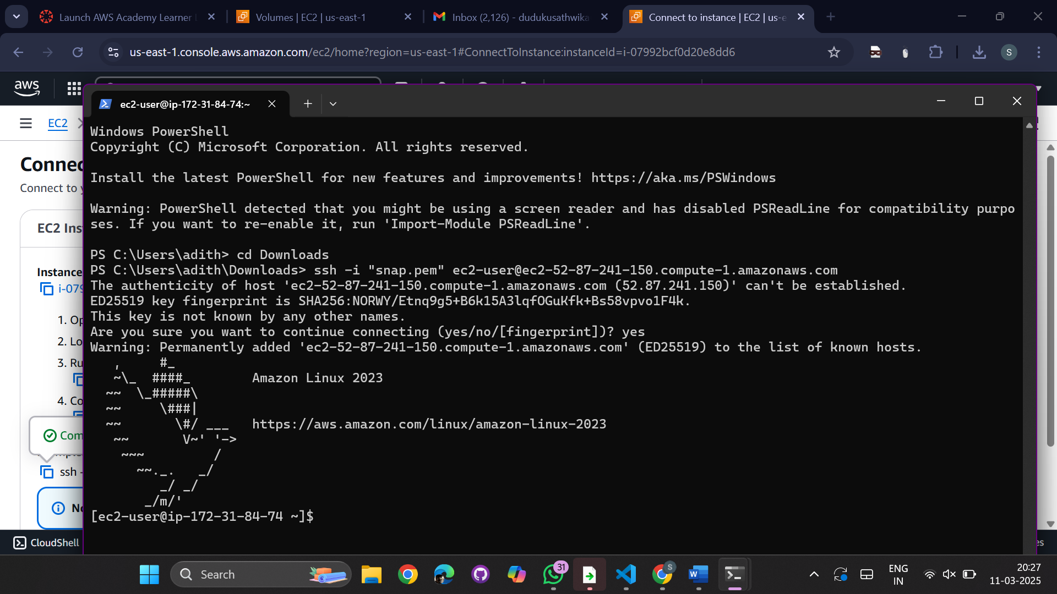

1. Sudo su 2. Lsblk -fs
2. 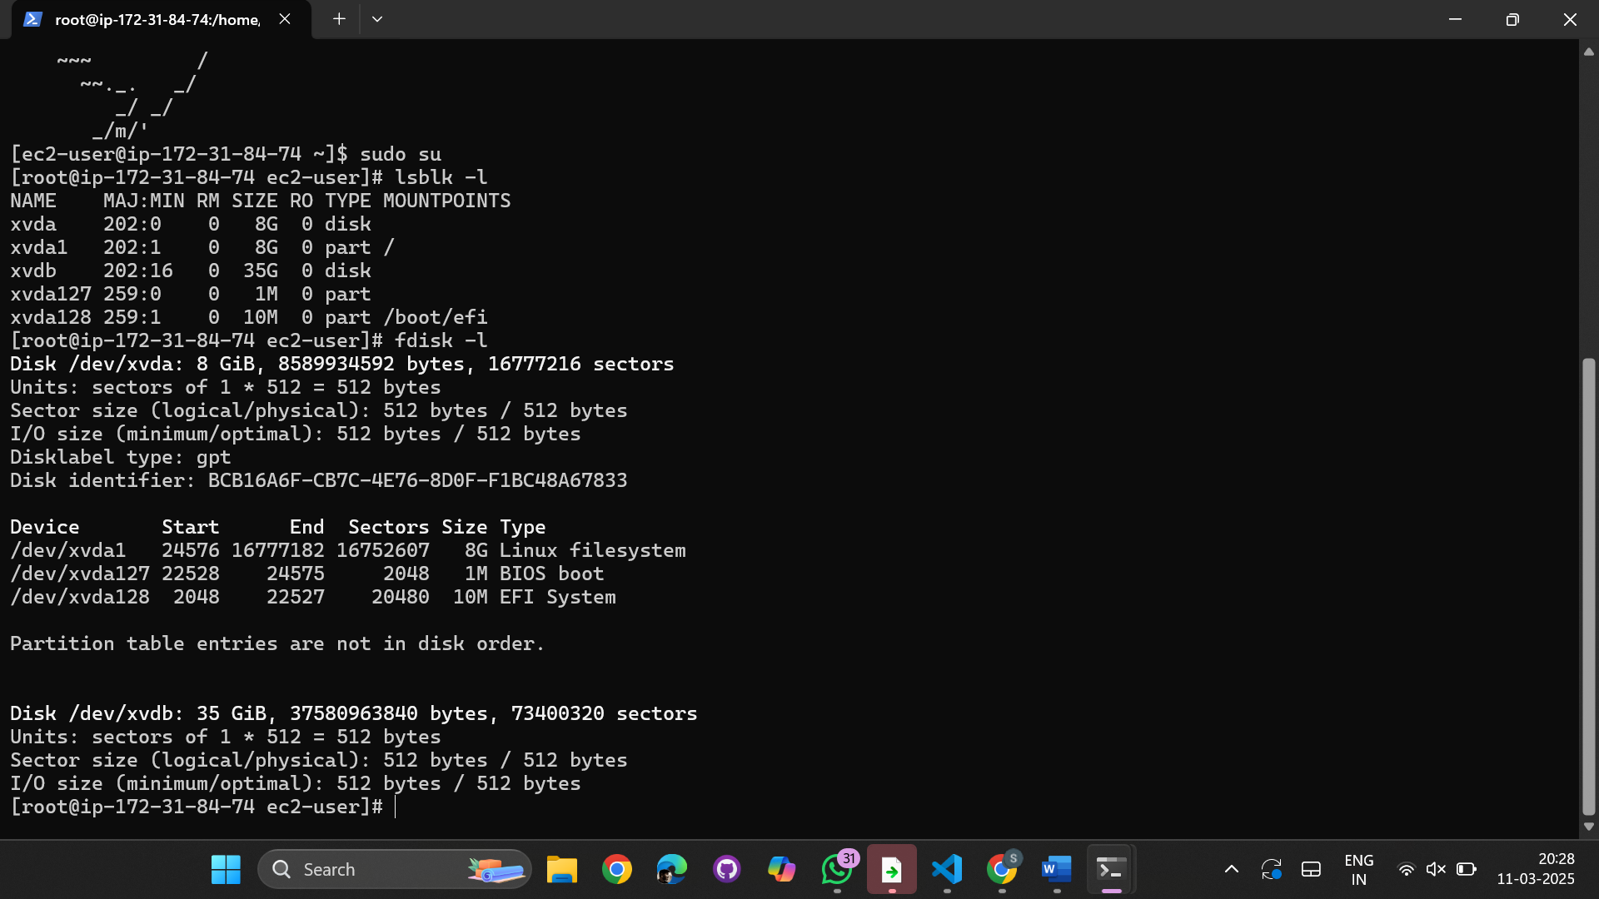  
   Fdisk /dev/xvdb

N – new partition

P – partition

W – write changes

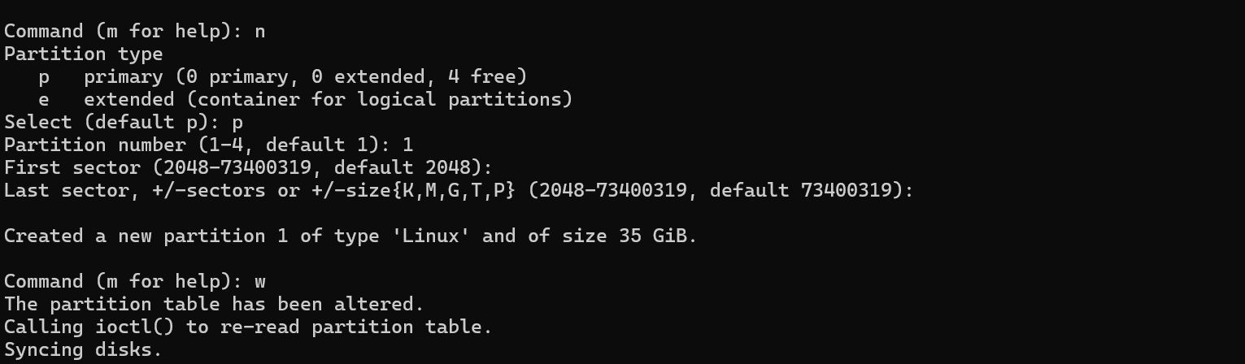  
Make file system -> Mkfs.xfs /dev/xvdb1

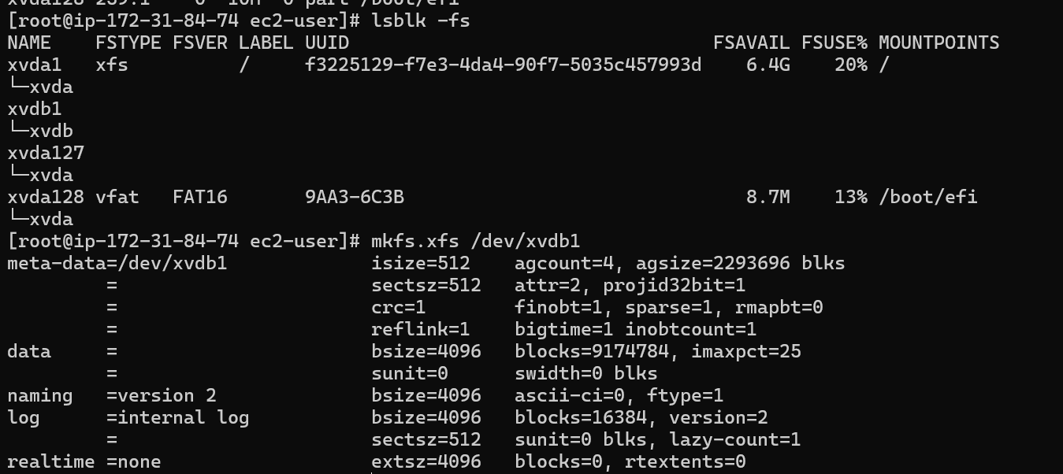

A new directory is created

Make directory to mount -> mkdir /mnt/cse

Mount the created directory -> mount /dev/xvdb1 /mnt/cse

Go to the directory cse

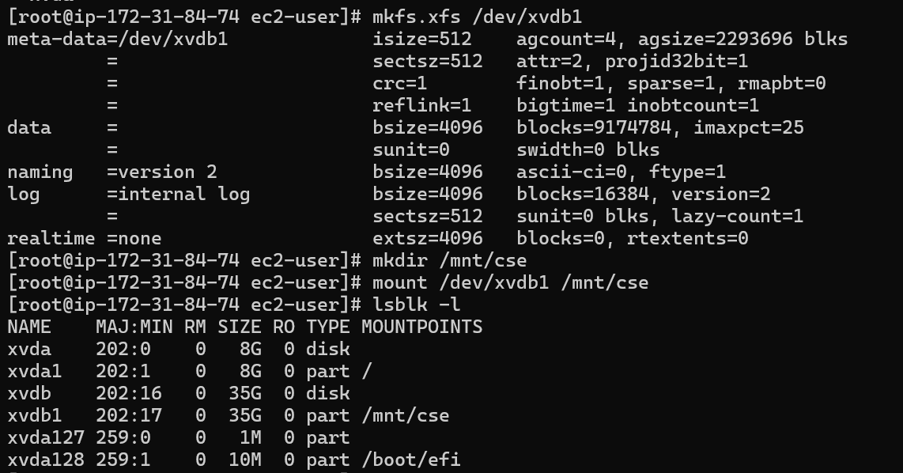

Copy the git hub repository for mavenjava

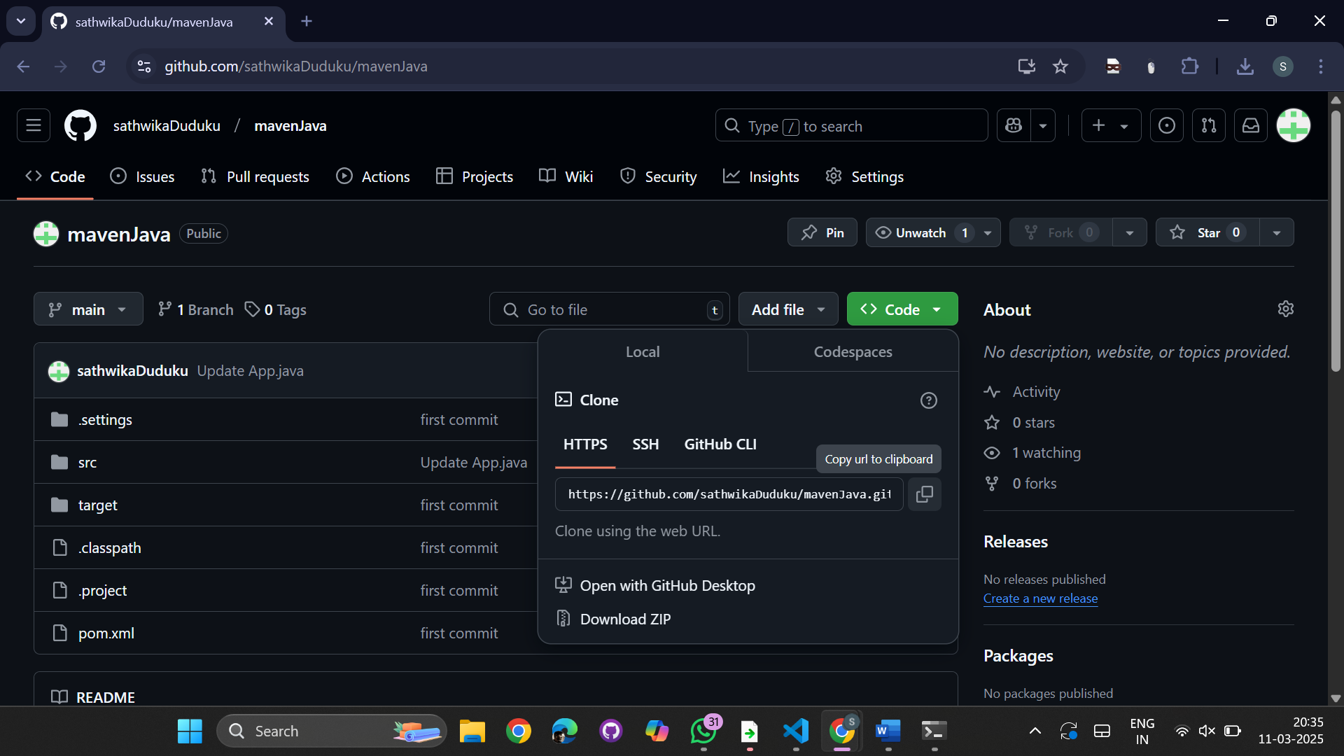

Now install git using -> yum install git

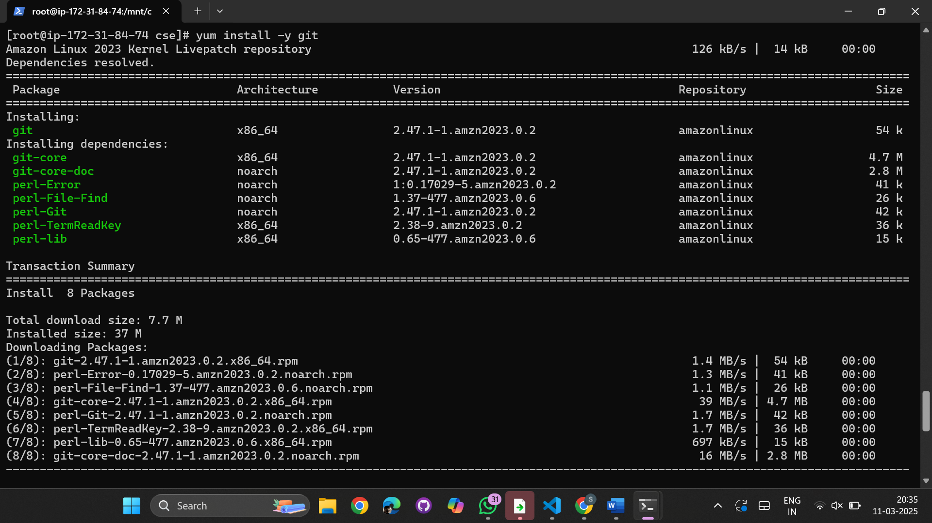

Clone the repository using git clone <https://github.com/sathwikaDudku/mavenJava.git>

List the files now -> ls

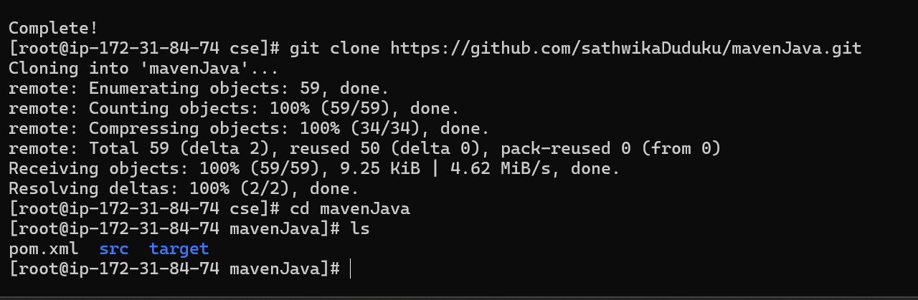  
Now we have to persist the volumes

Open an editor using -> vi /etc/fstab

Go to insert mode by clicking i

Write -> dev/xvdb1 /mnt/cse xfs deafults 0 0 -> esc -> :wq

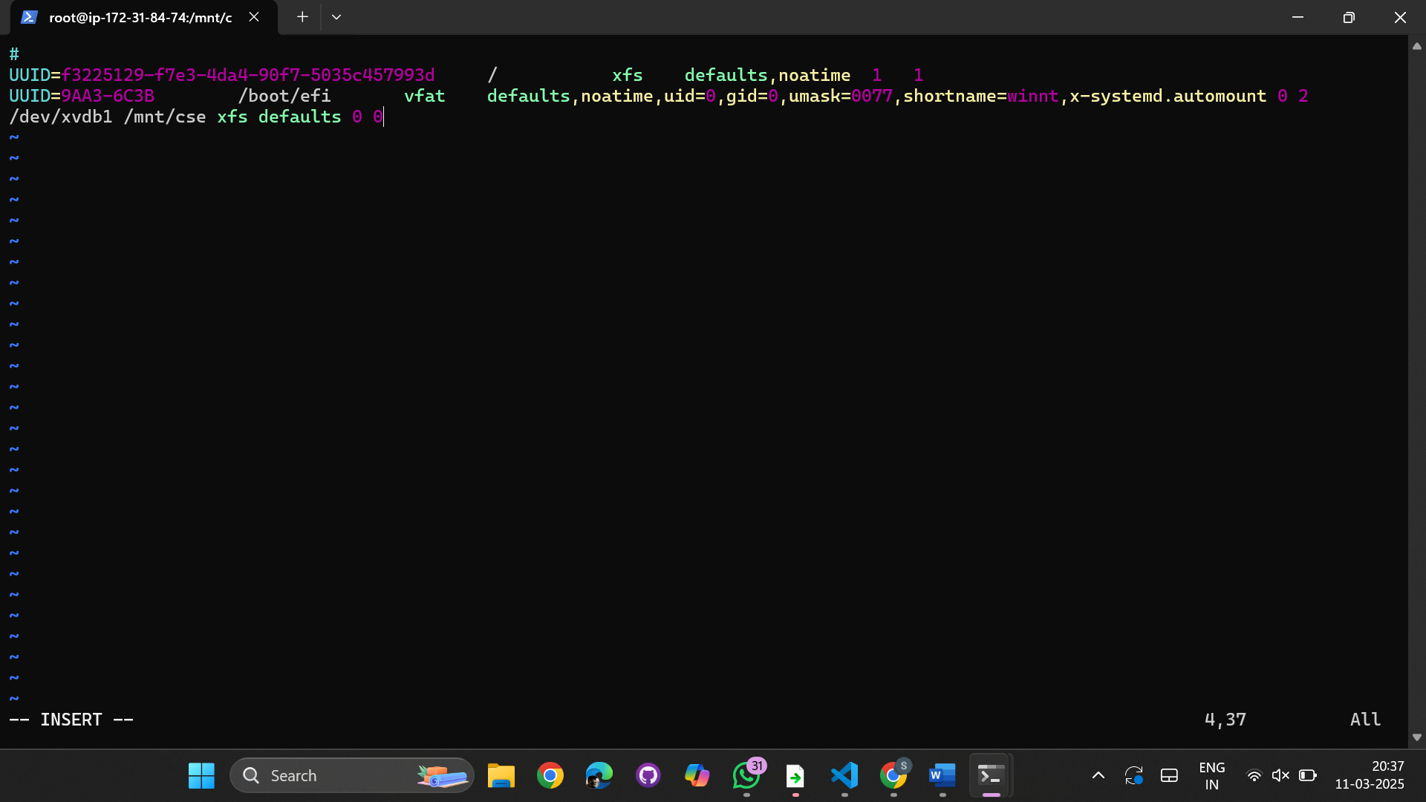

Now unmount the directory using -> umount /mnt/cse

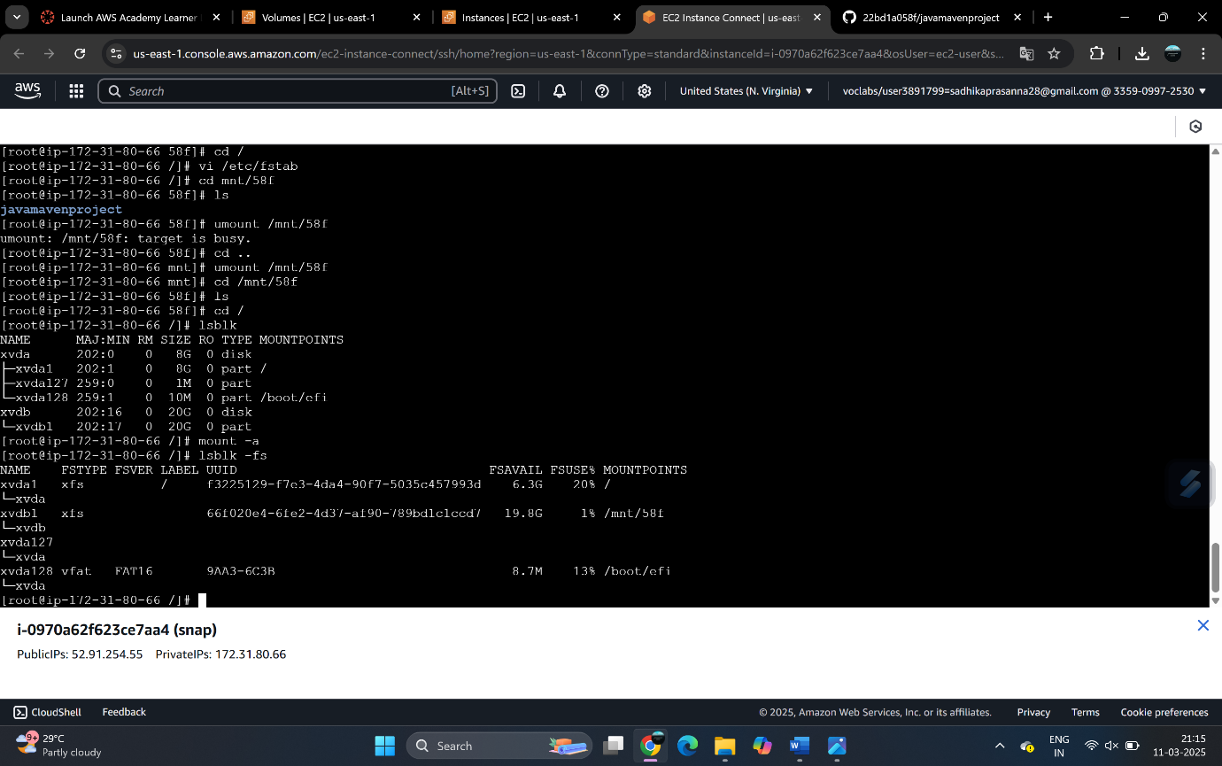

Then execute cd /mnt/cseto check if files are present using ls (No files will display as unmounted)

Execute mount -a -> to re mount the directory

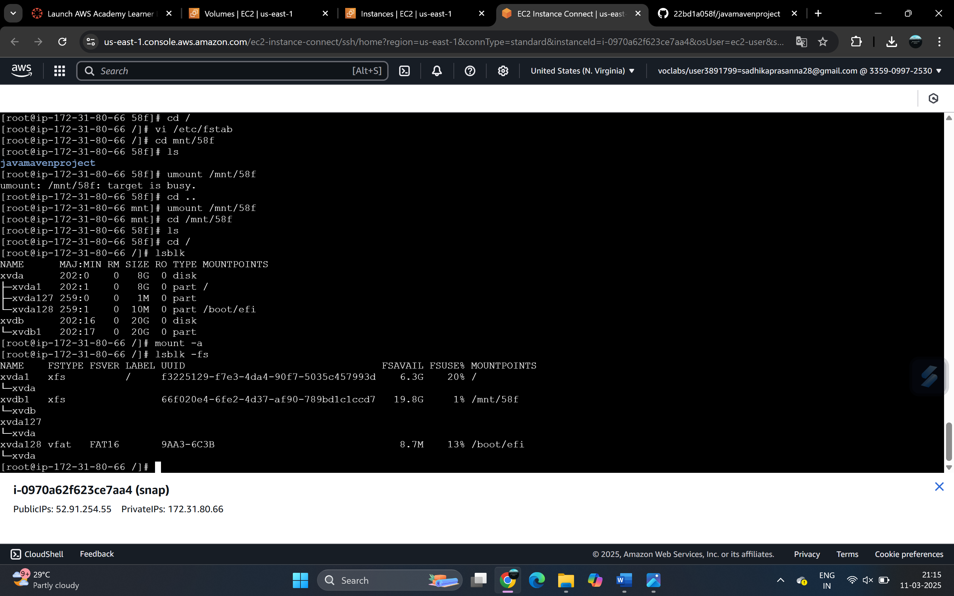

Execute lsblk -fs to see if the mount points are present

Go to Instances -> EBS -> Volumes

Go to Actions -> Create snapshot

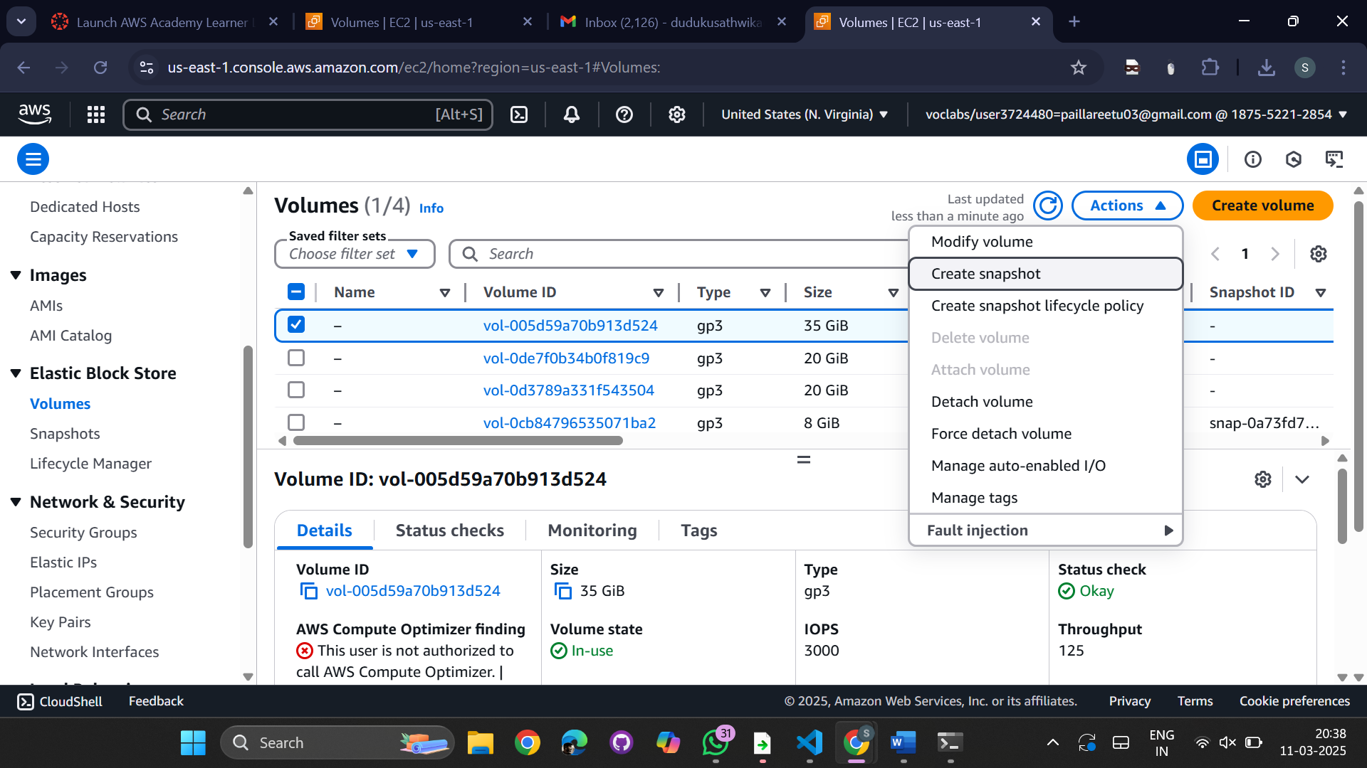

Give description with region (snap) -> Create snapshot

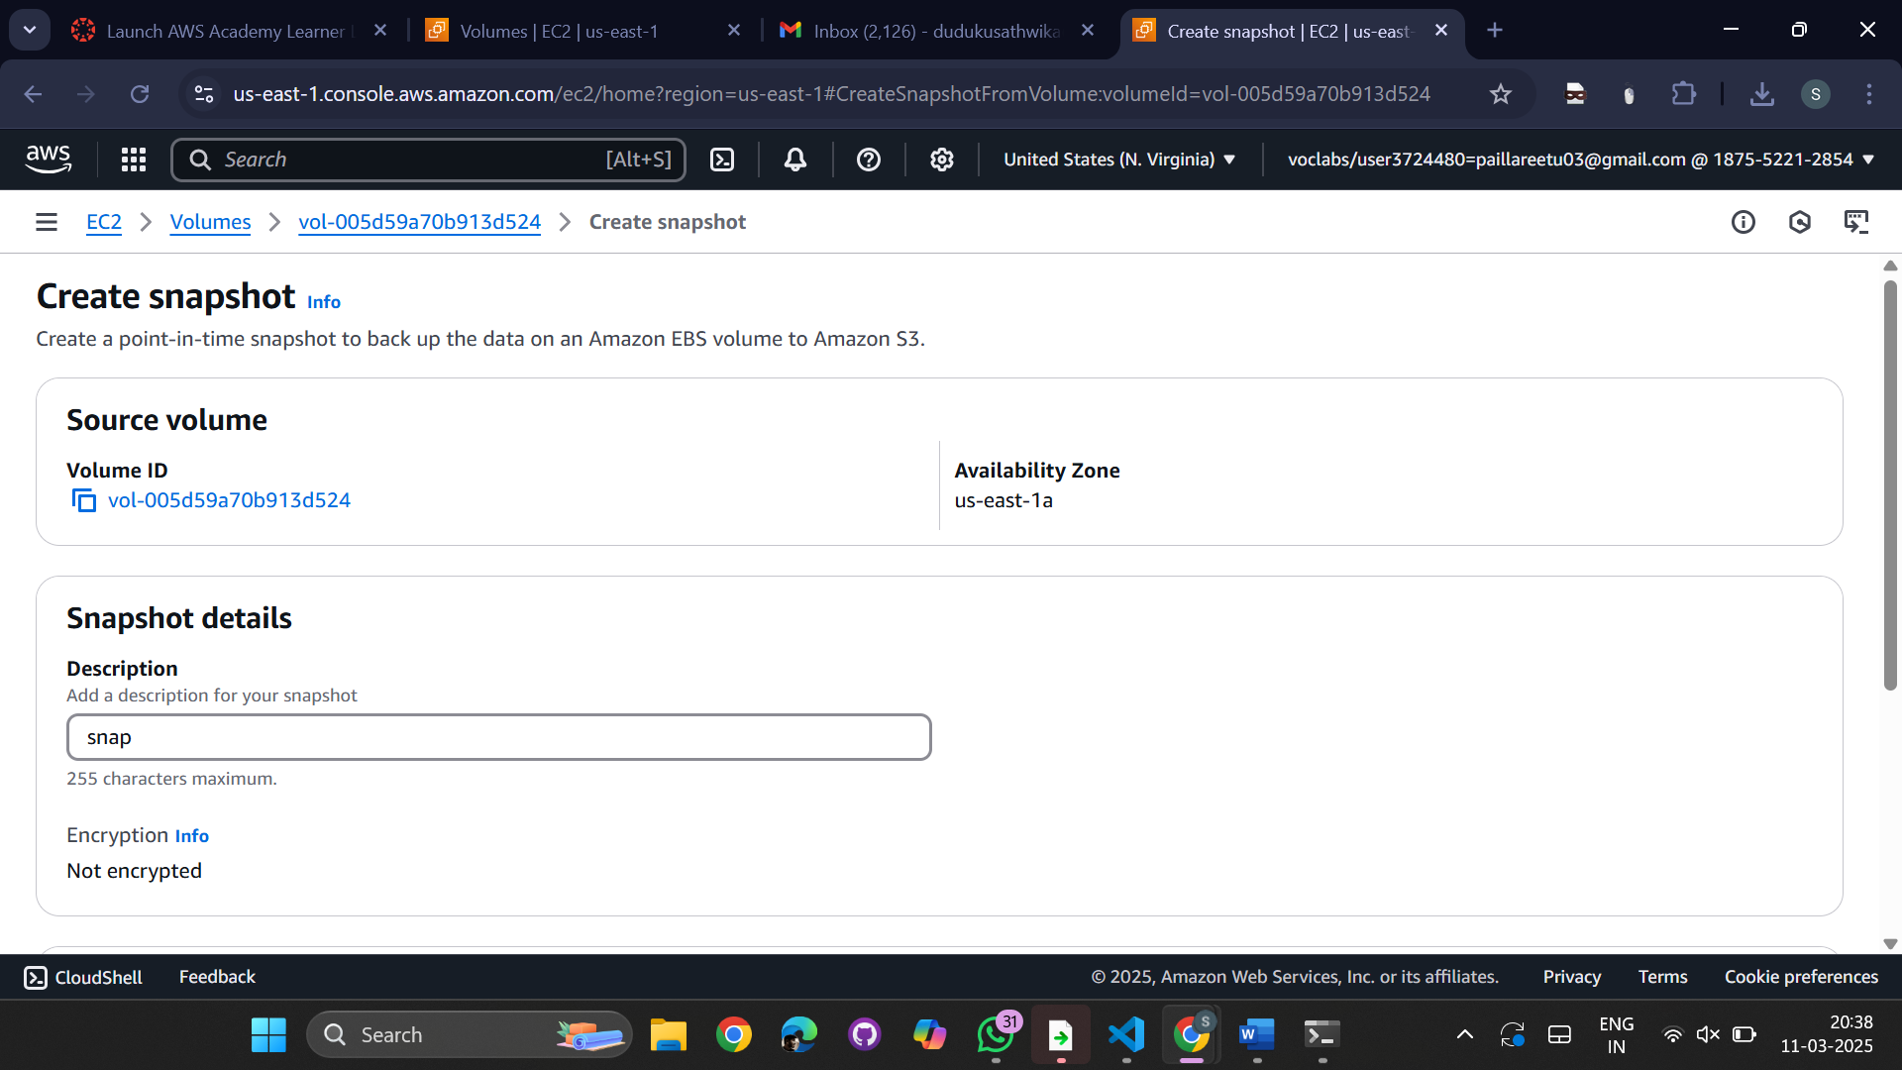  
  
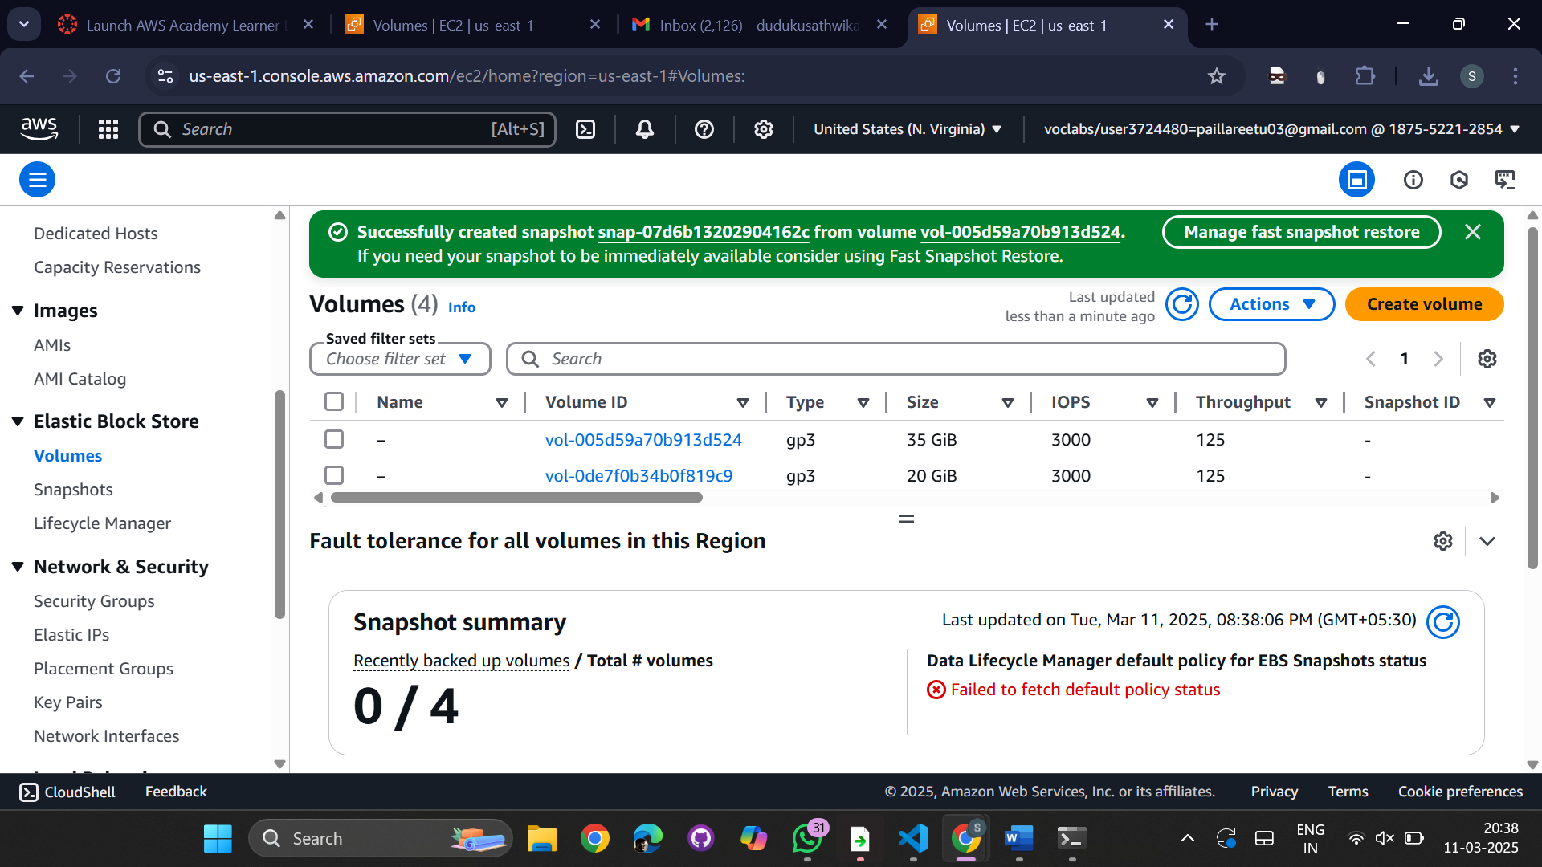  
Go to EBS -> Snapshots

We can see the snapshot which we have created

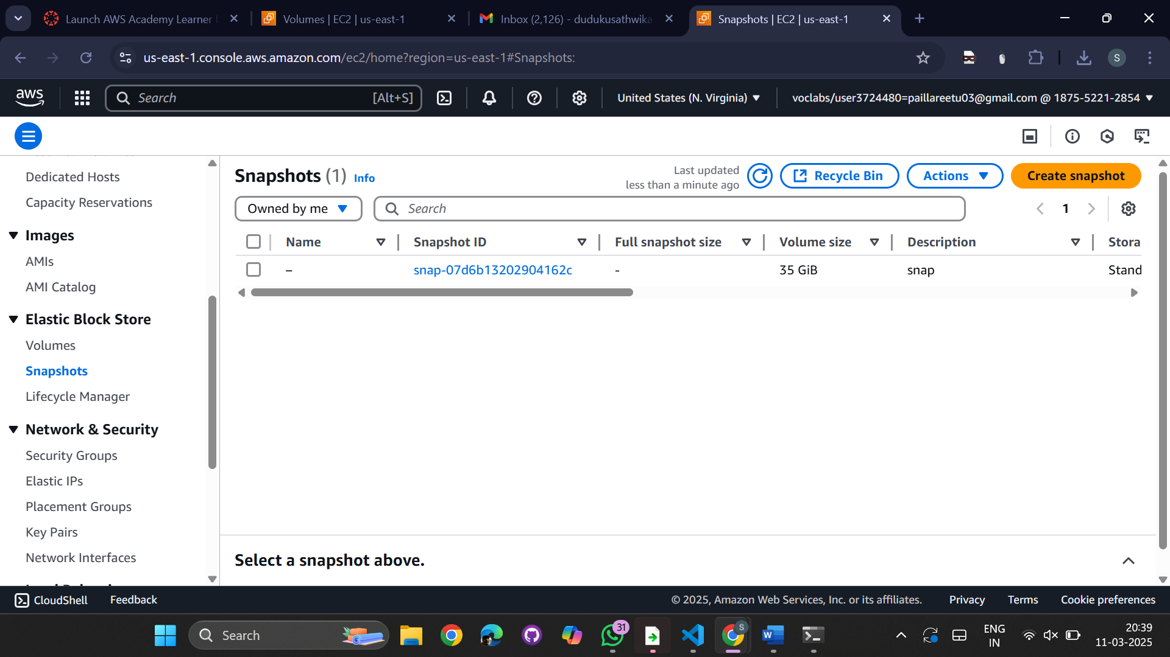  
  
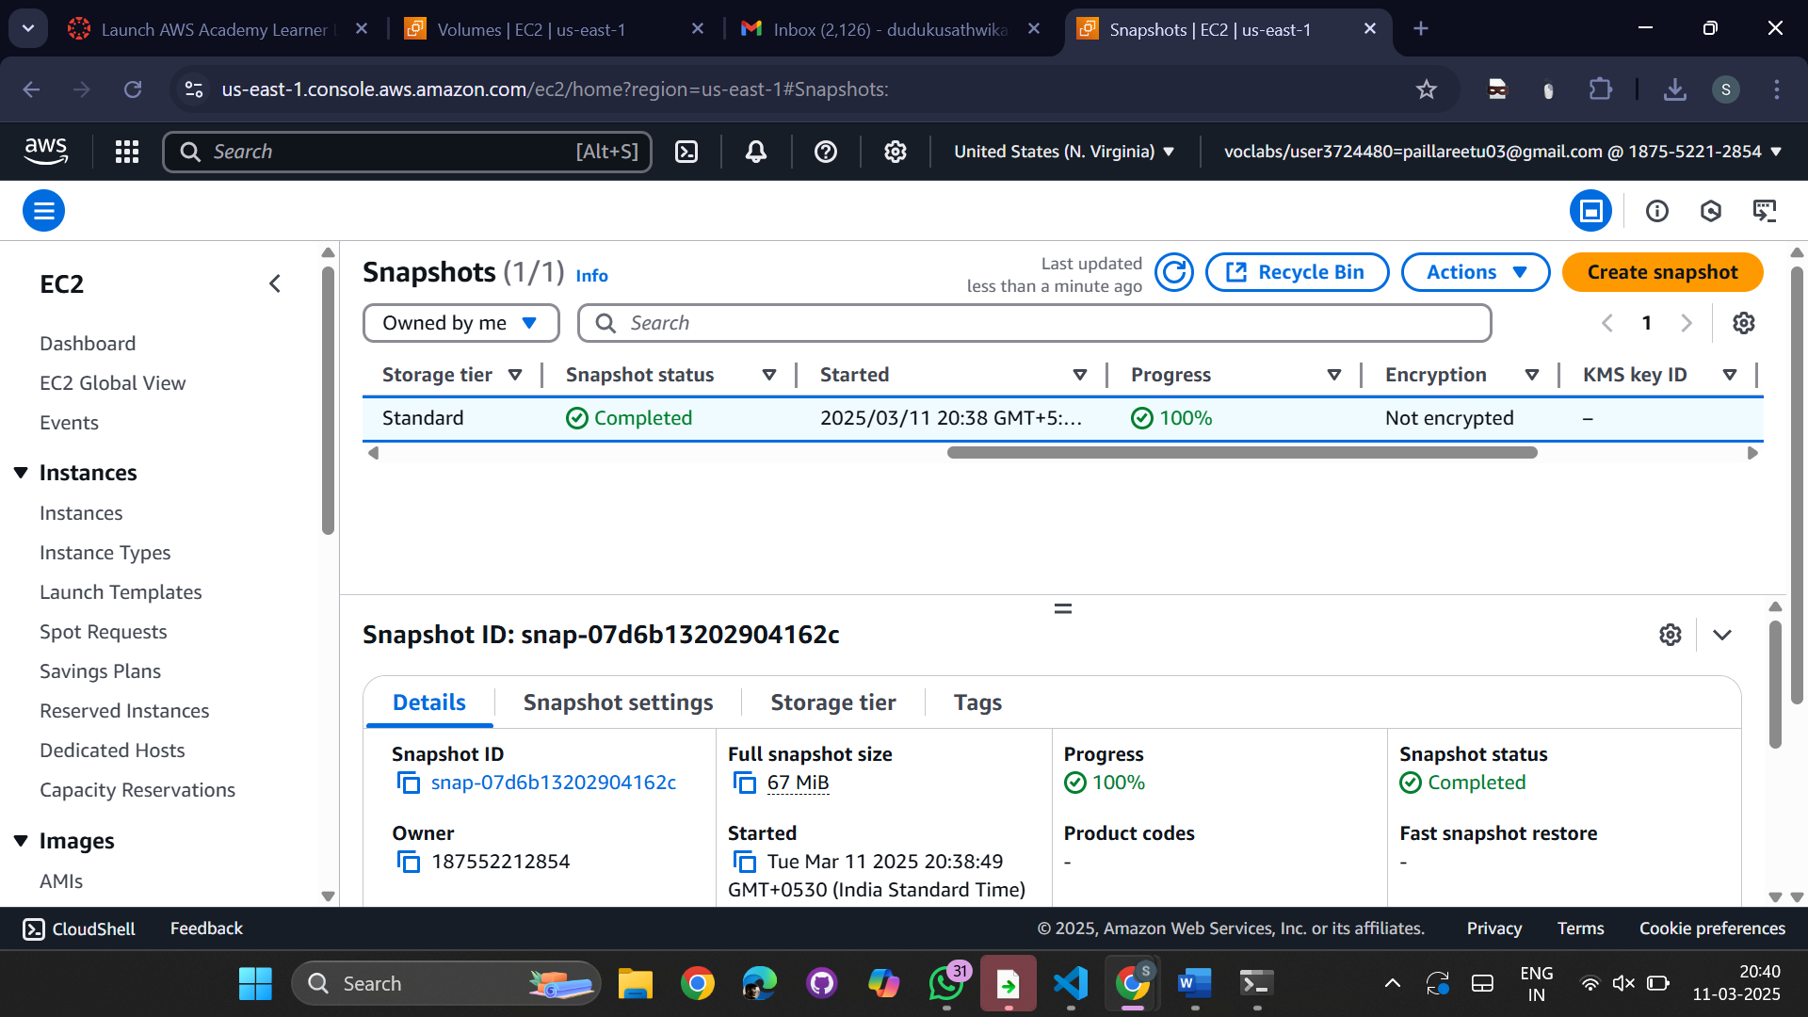

Select the snapshot created -> Actions -> Copy the snapshot

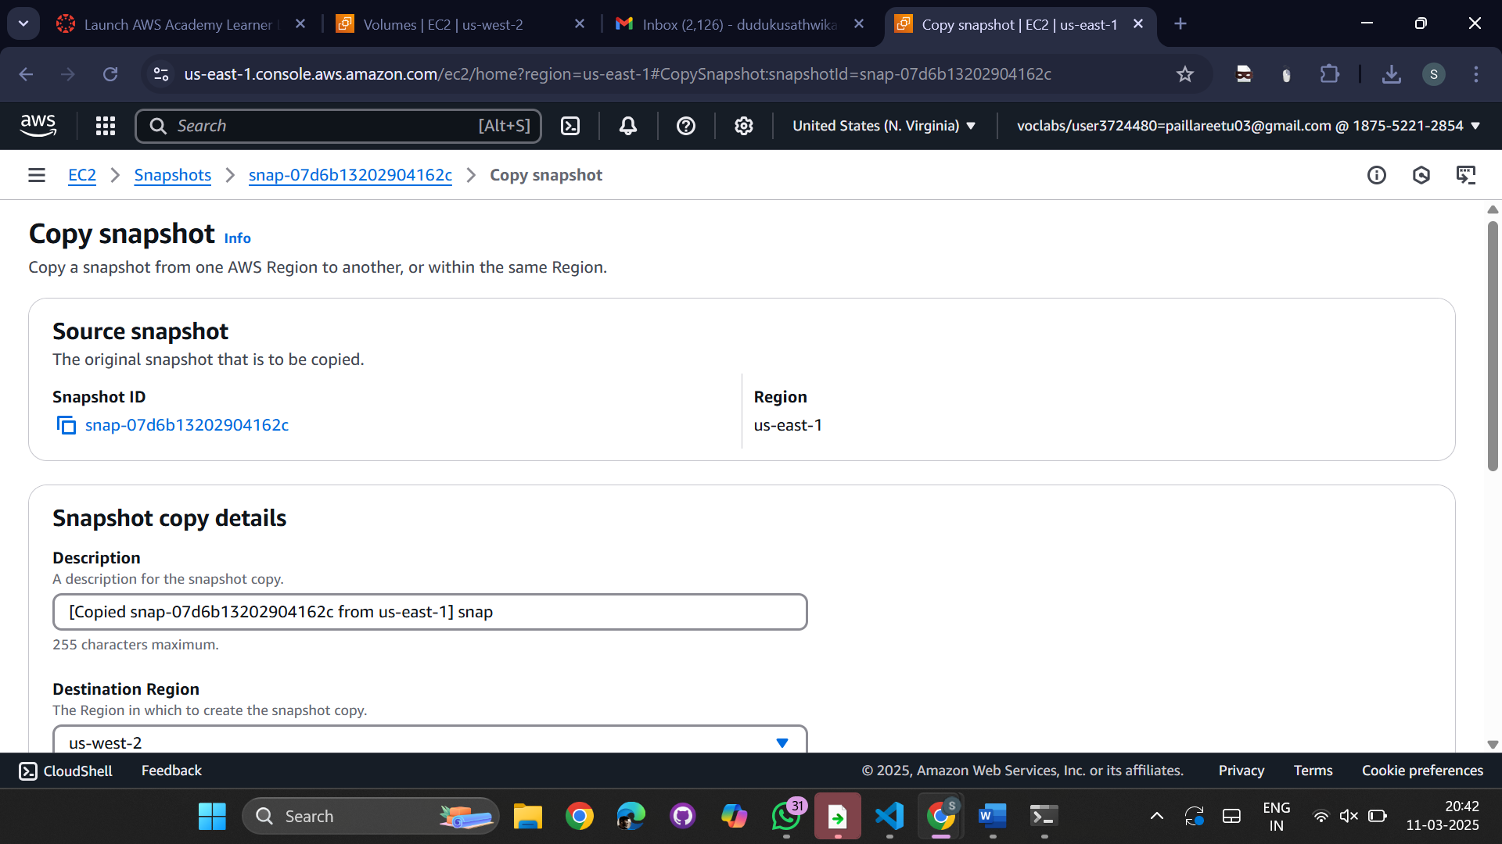

Select the region details to which we want to copy this snapshot (us-west-2)

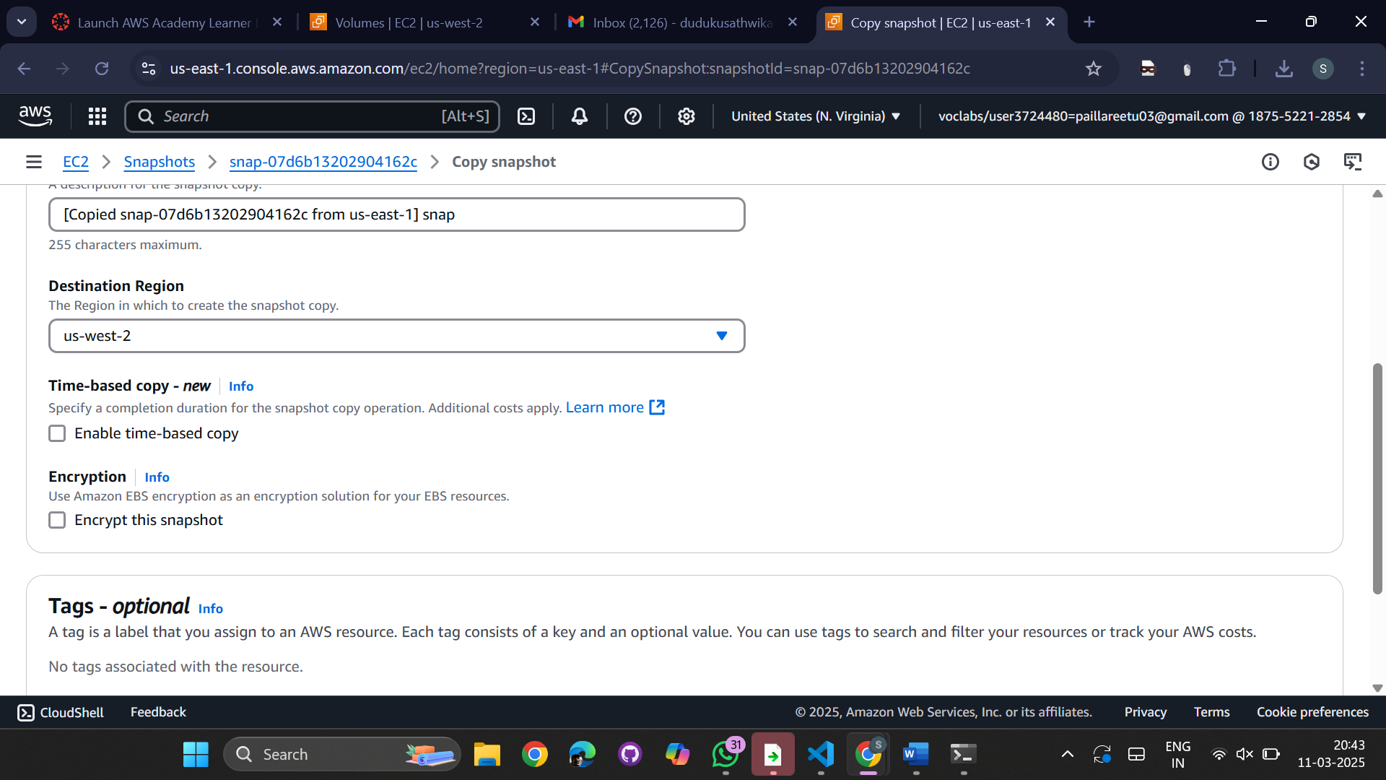  
successfully snapshot is copied  
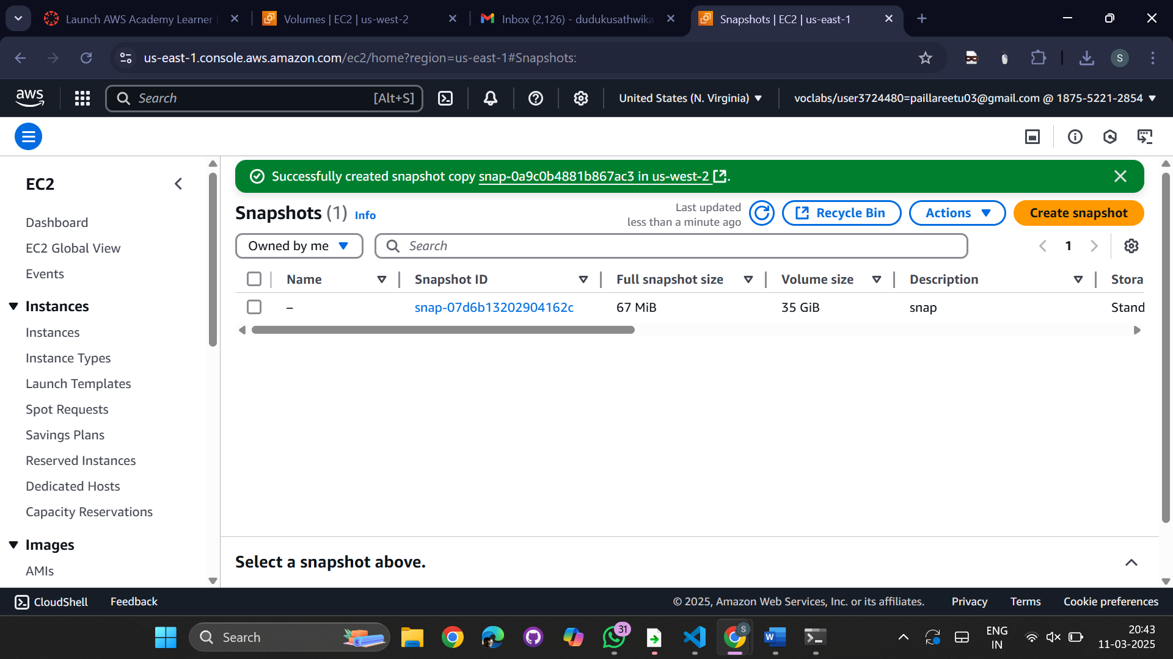  
  
Copy the snapshot

Change the region to -> us-west-2 ->

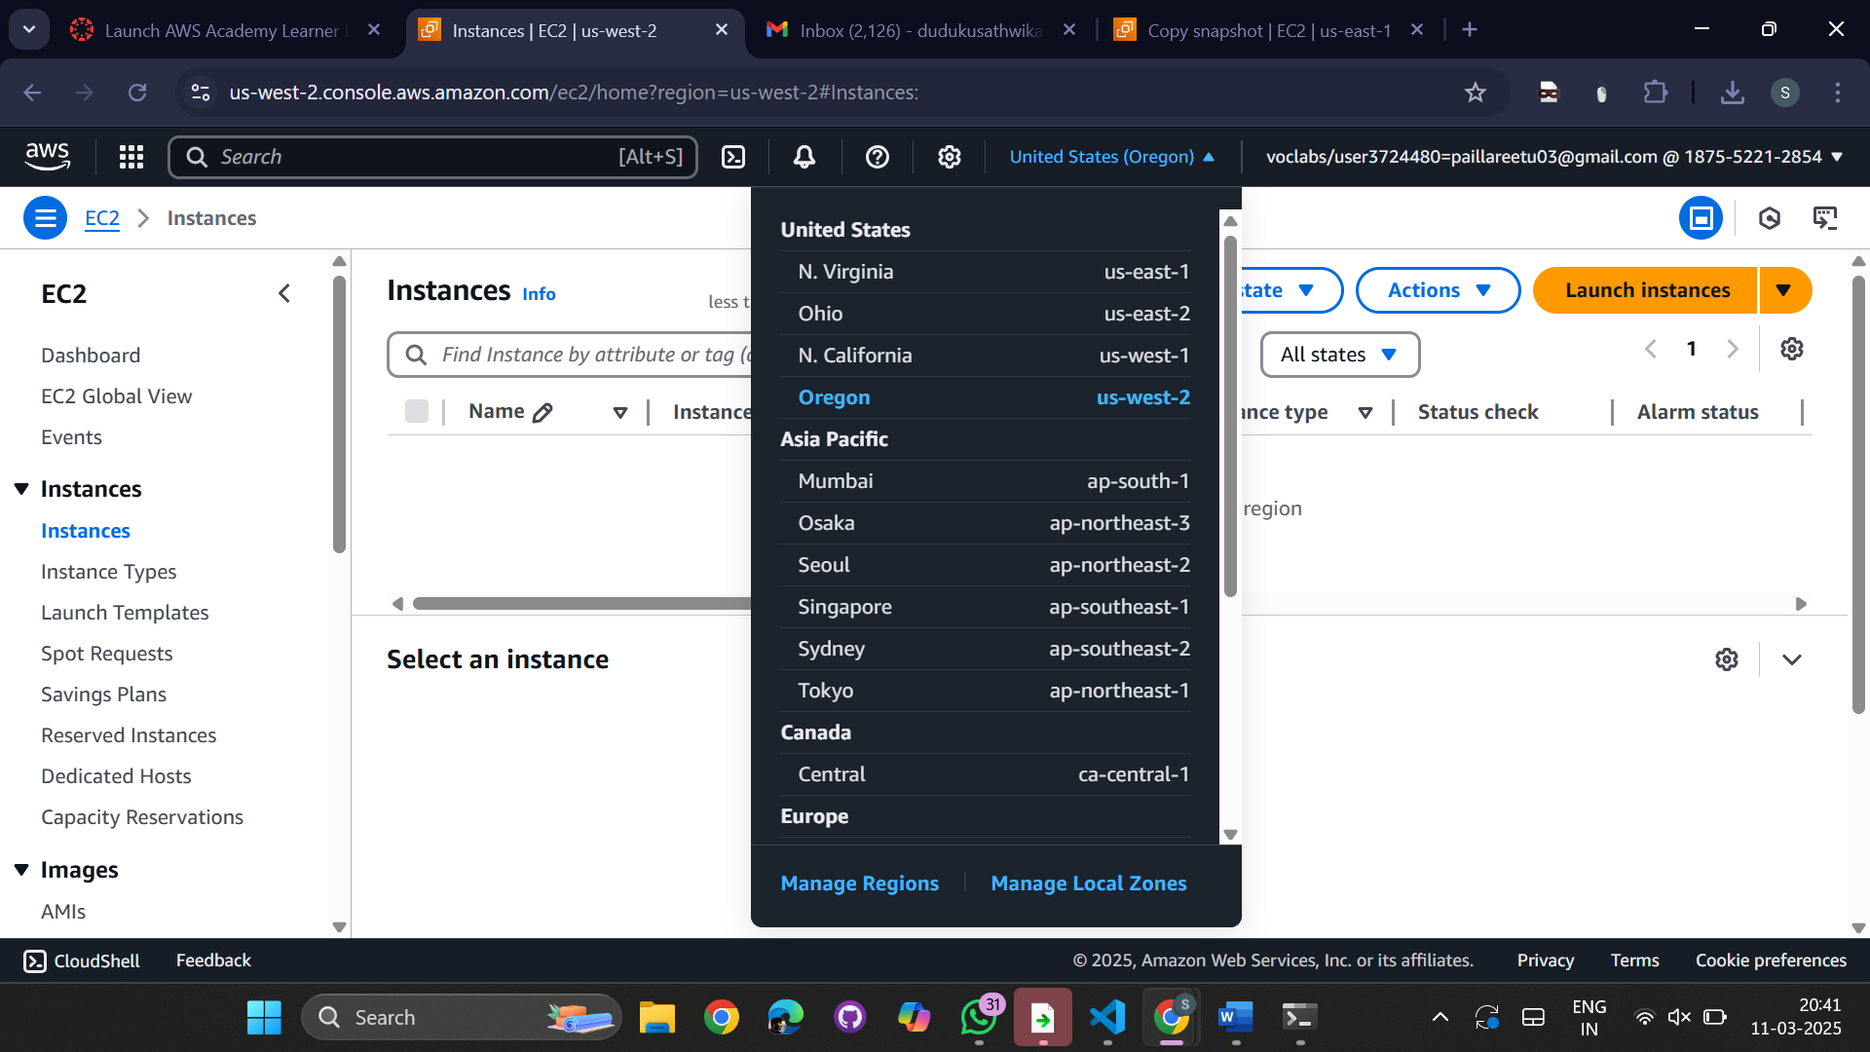

We can see that there is no volume is present in the ebs  
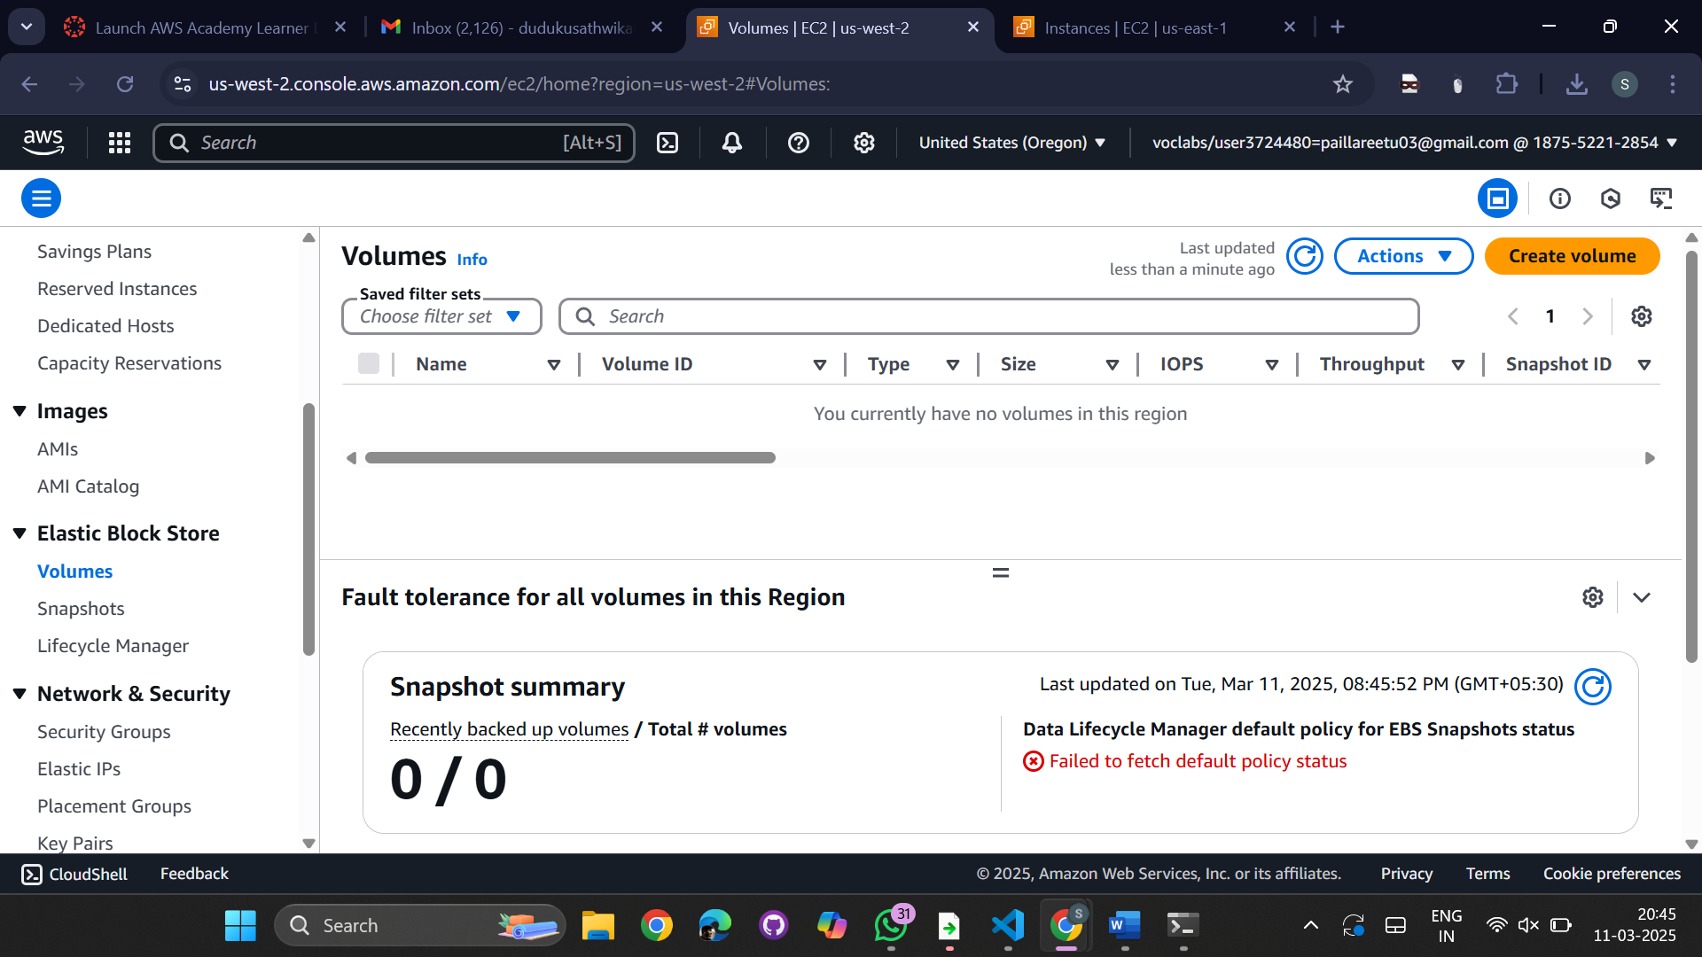  
Go to snapshots (We can see the already created snapshot)

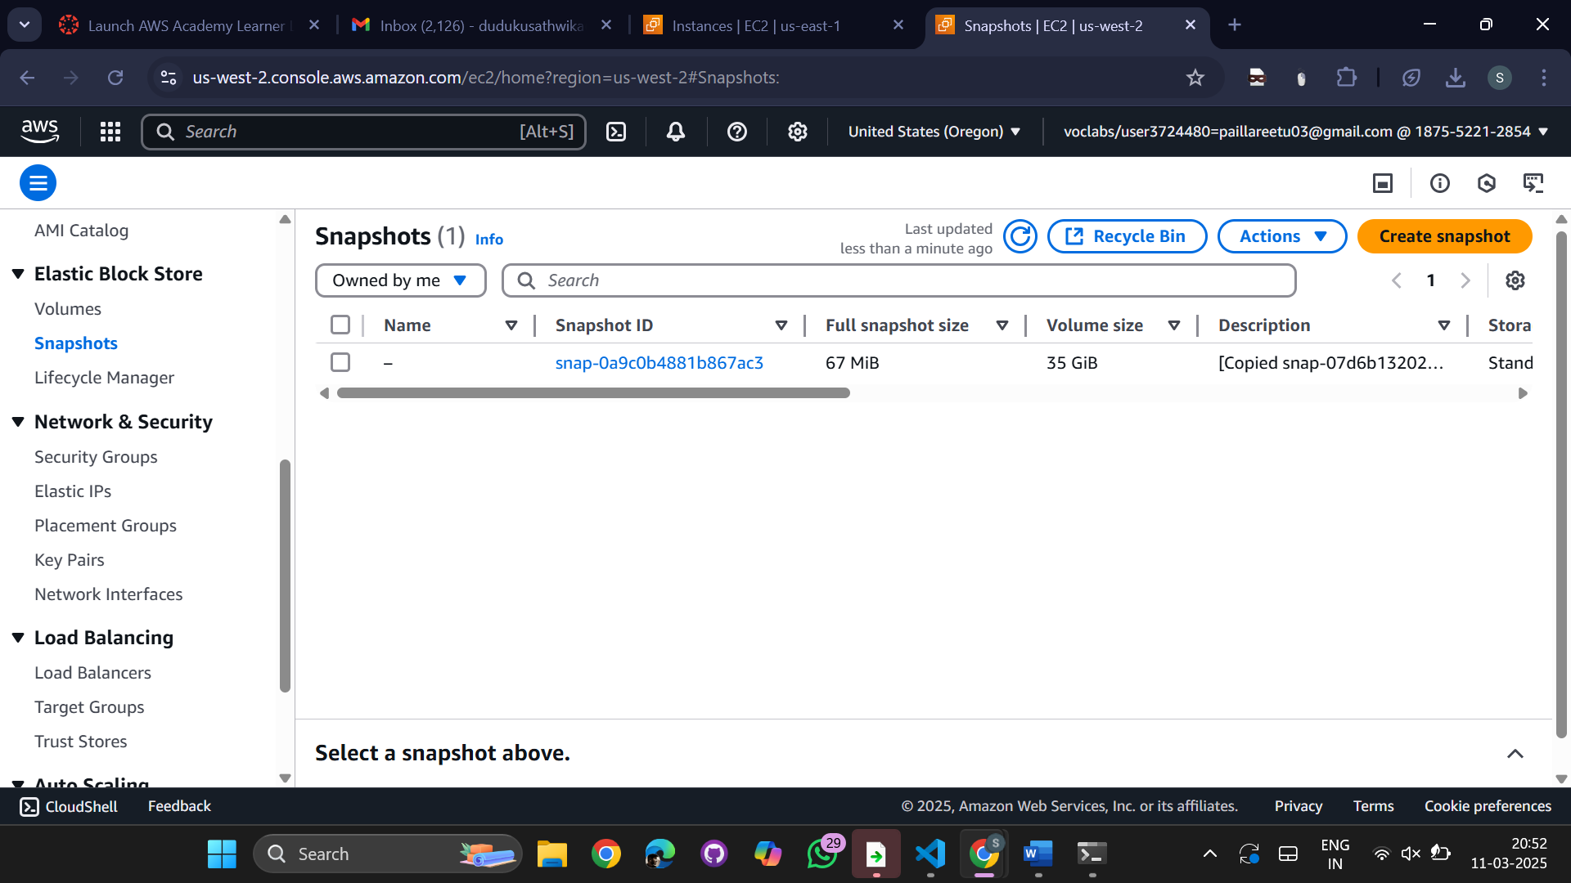

Now select the snapshot go to Actions->select create volume from snapshot  
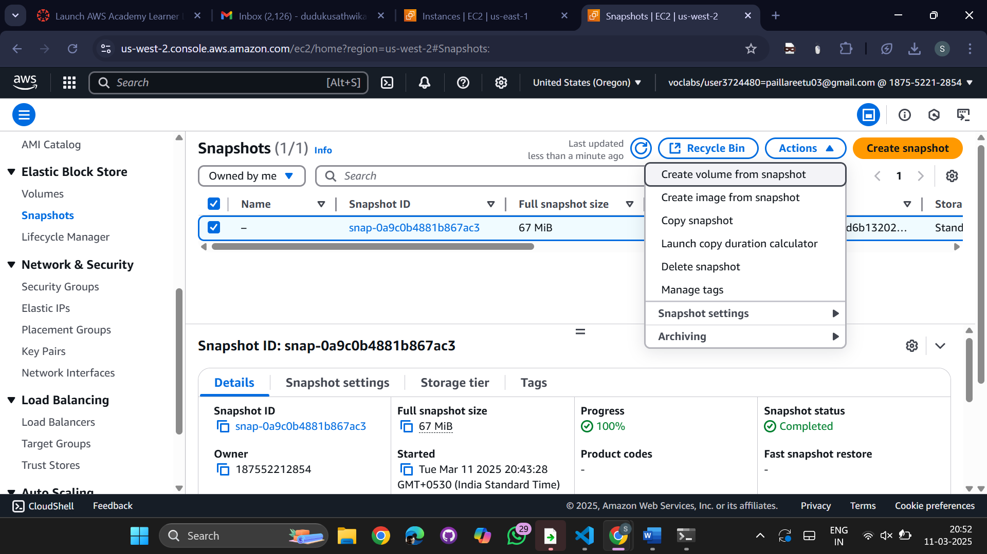

Select the availability zone (us-west-2a)

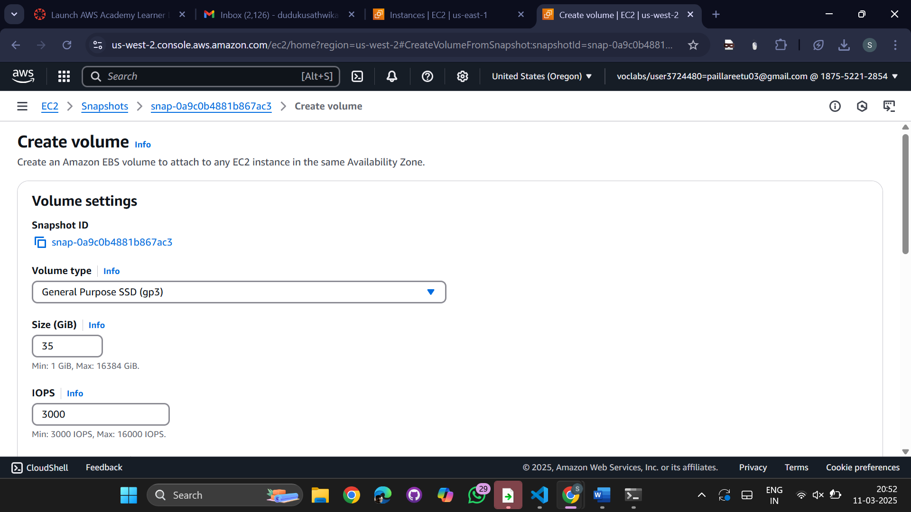

We can see the volume created from snapshot  
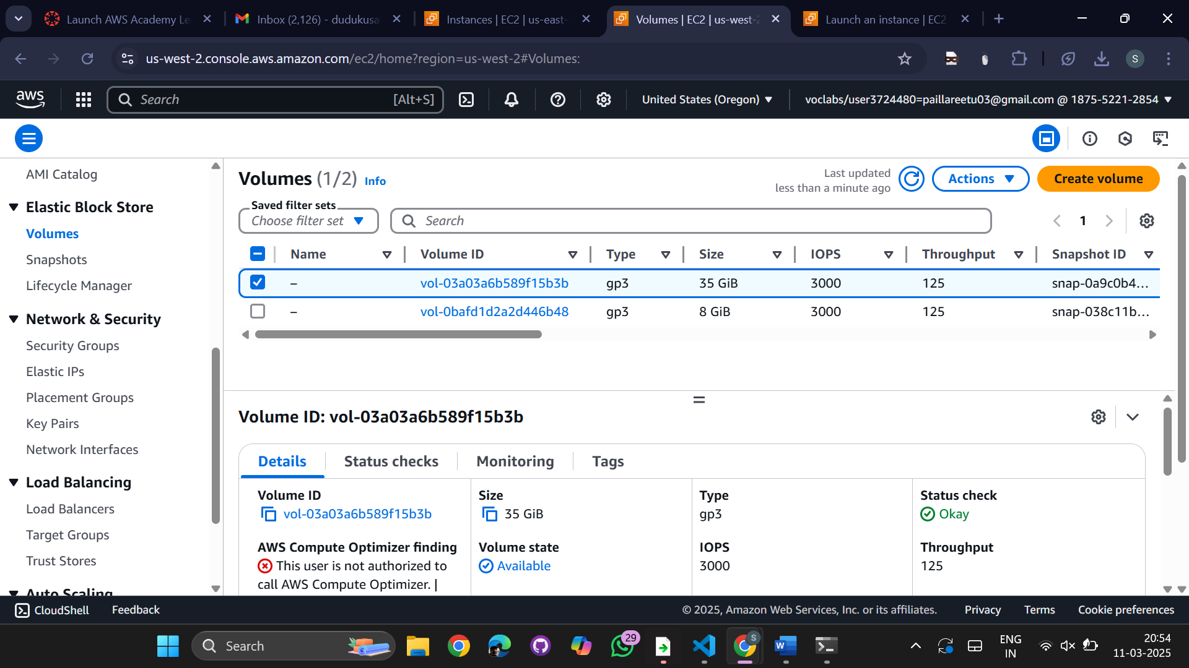  
  
  
  
  
Go to instances-> Name -> snaporgeon, OS -> Amazon Linux, Instance type -> t2.micro

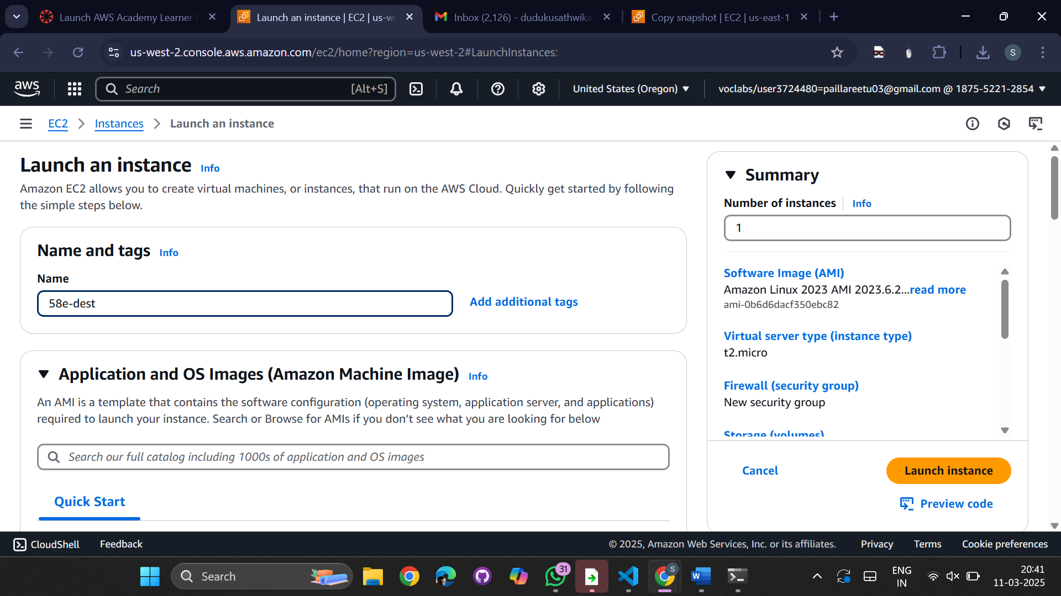  
Edit network settings

Select subnet -> us-west-2a

Launch instance

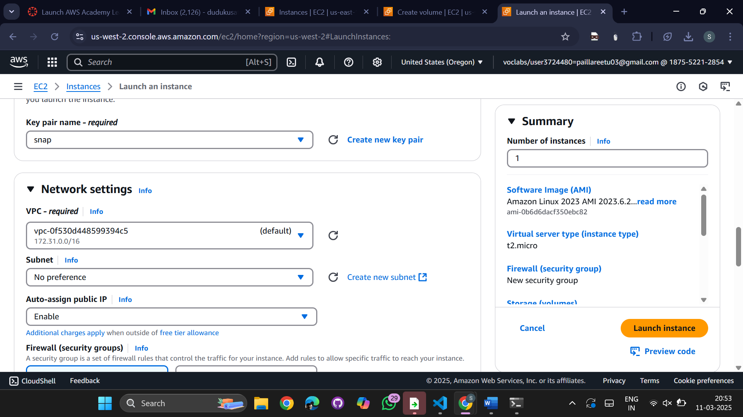  
Go to volumes -> Actions -> Attach the volume

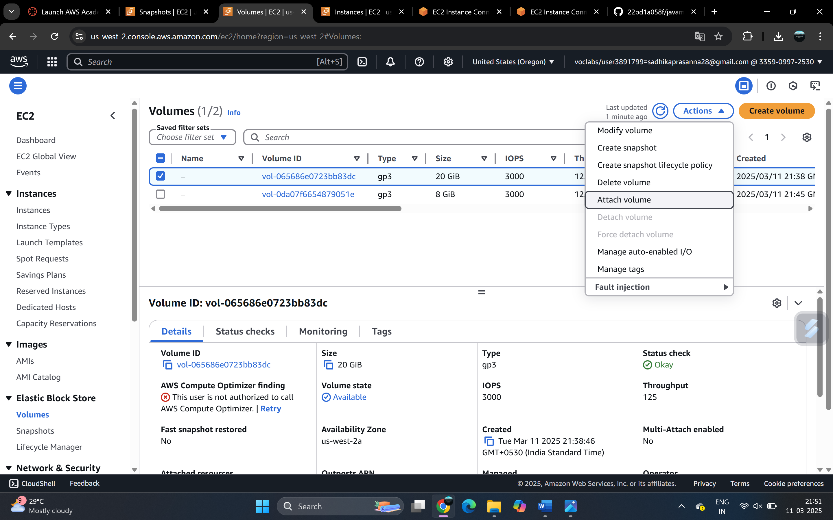

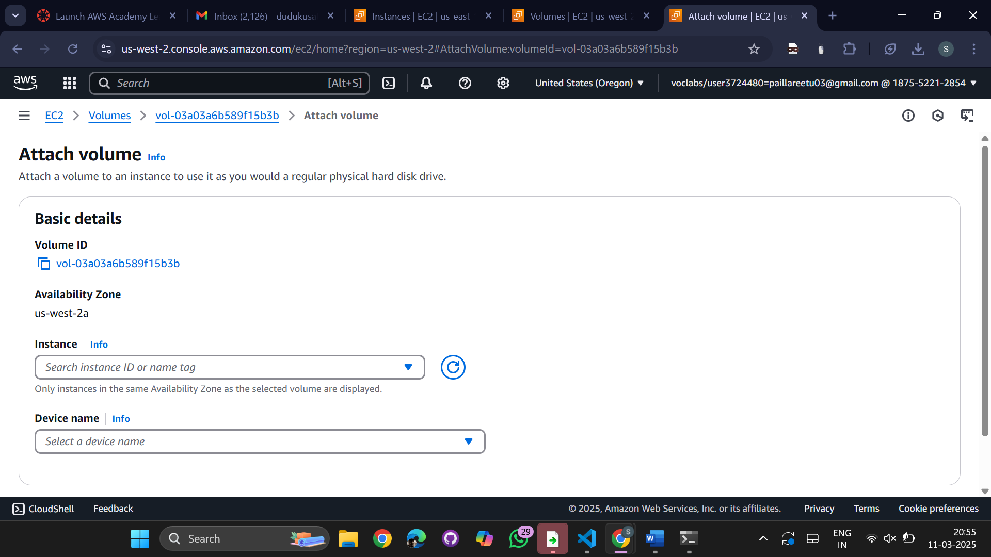

Select the Instance (snaporgeon) & Device name as -> dev/sbd -> attach volume

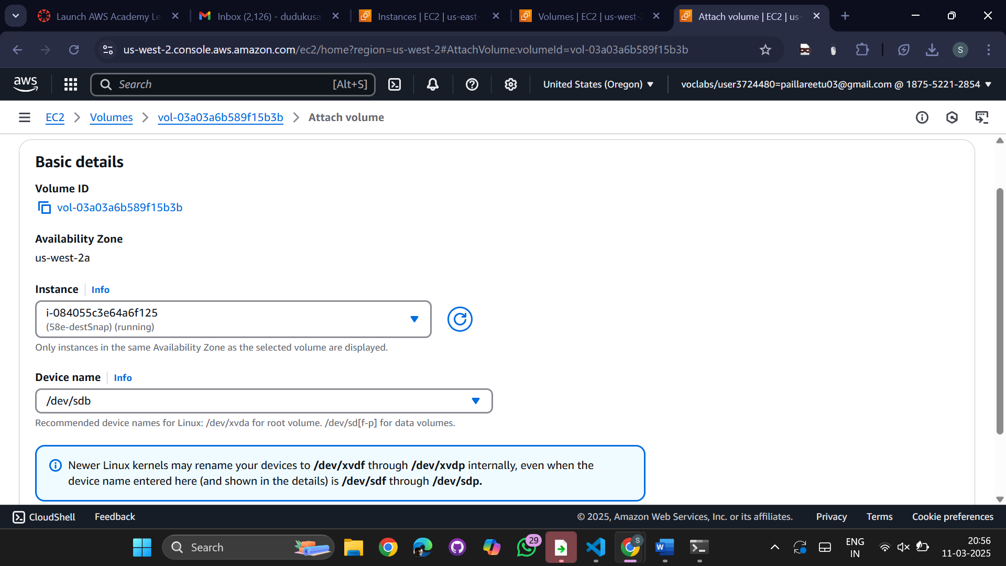

Connect to the EC2 Instance

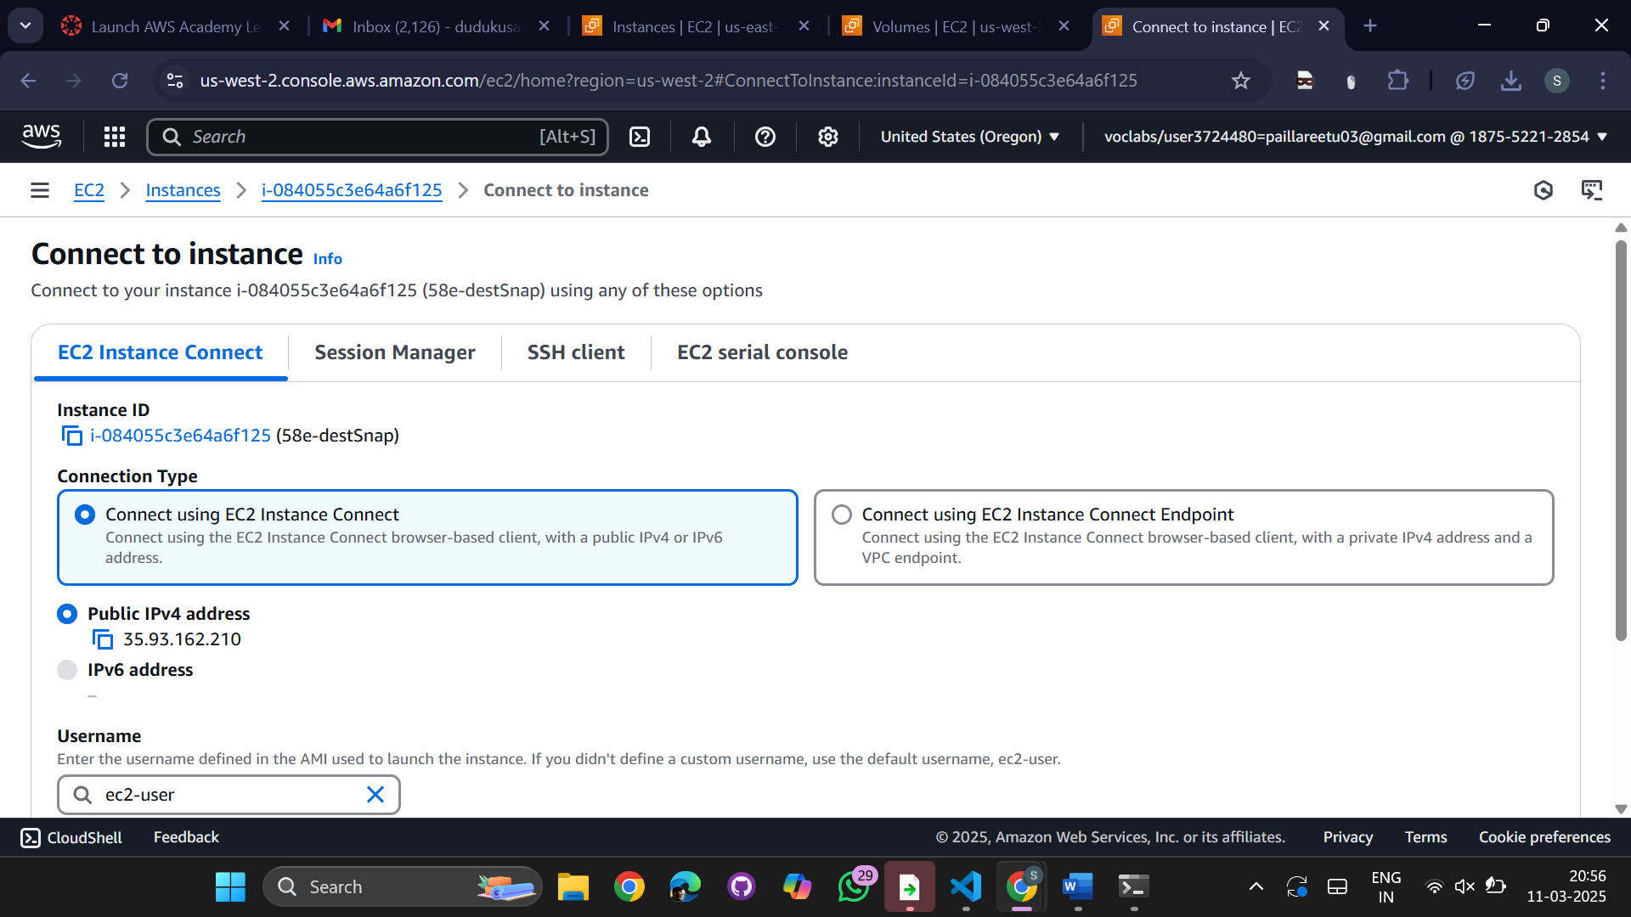

Execute the commands

Sudo su -> lsblk -fs

Make directory -> mkdir /mnt/cse1

Mount the directory

Lsblk -fs

Cd /mnt/cse1

Ls -> will list the files which we have added from snapshot  
  
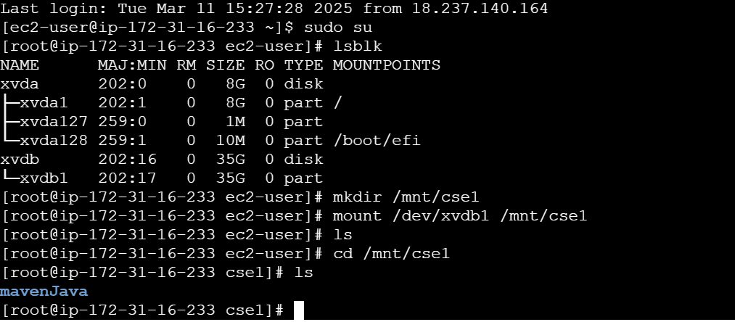

EFS

Creation of EFS i)Create the EC2 instance of different AZ's ii) Create the Sg's groups with NFS and attach to ec2 machines iii) Create EFS and mount it iv) Connect the EC2 instances and mount NFS for file sharing NOTE :- See the file is enable for other AZ's

Create a new instance

selecting Amazon linux (AMI) and t2.micro as storage and CPU and create a new key pair

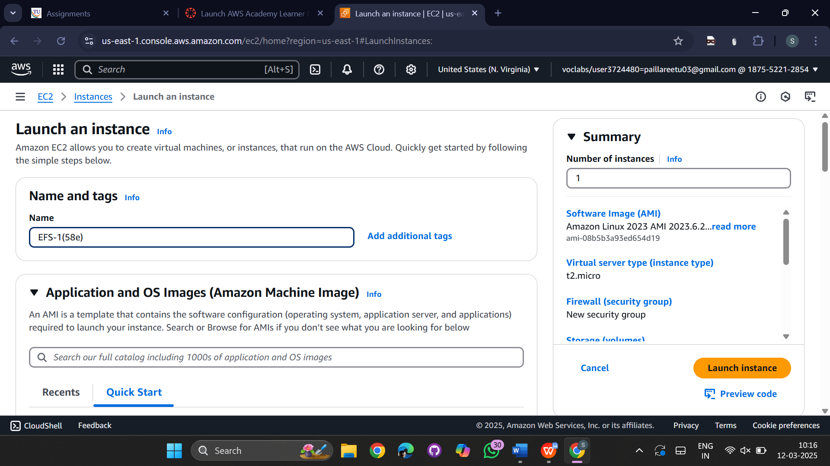

Create a new key pair ->choose .ppk key

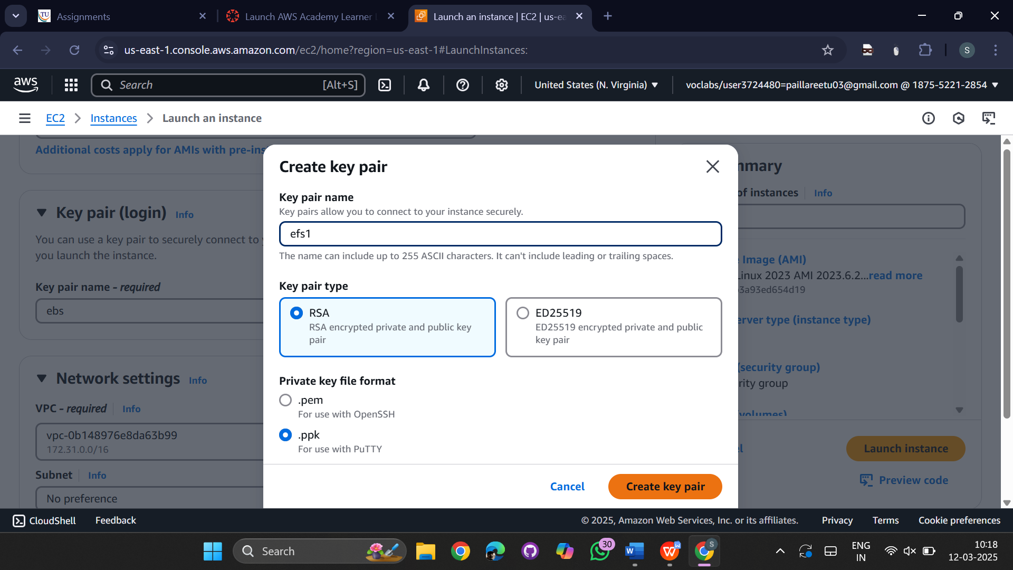

Go to network settings-> click on edit->subnet->choose us-east-1a

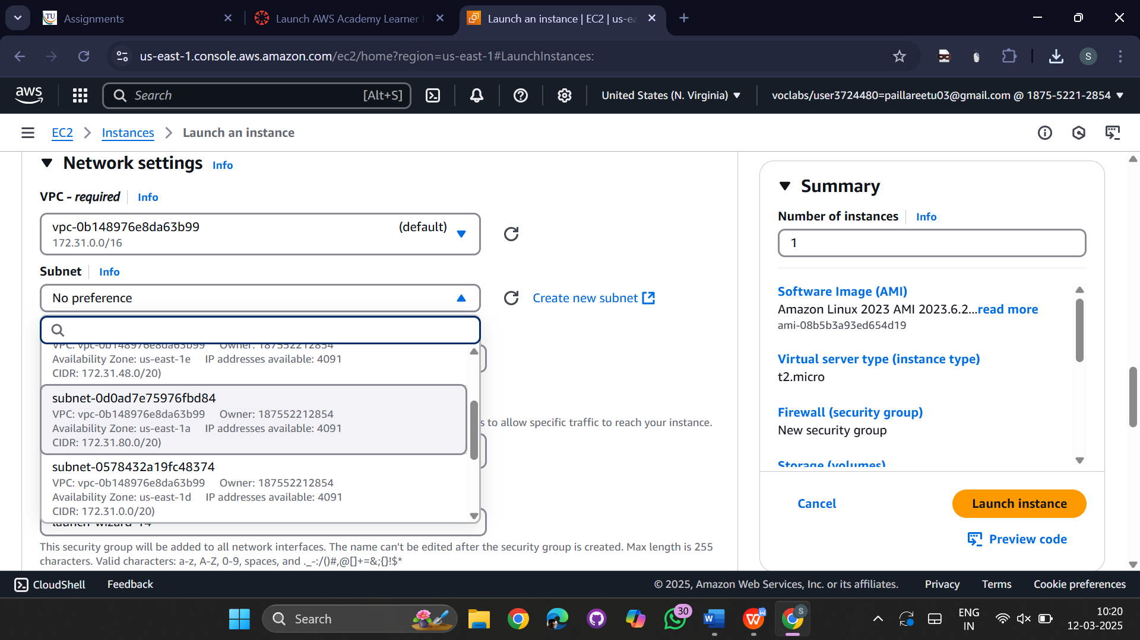

Change the security group name to EFS-NFS

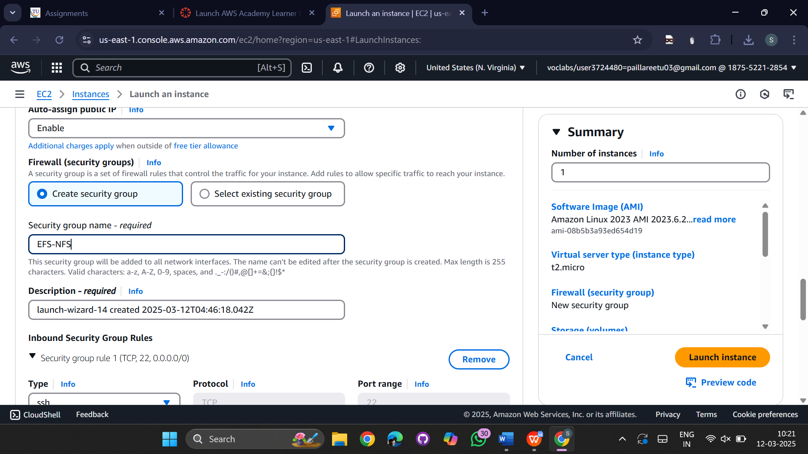

Create a new security group

Select type ->NFS

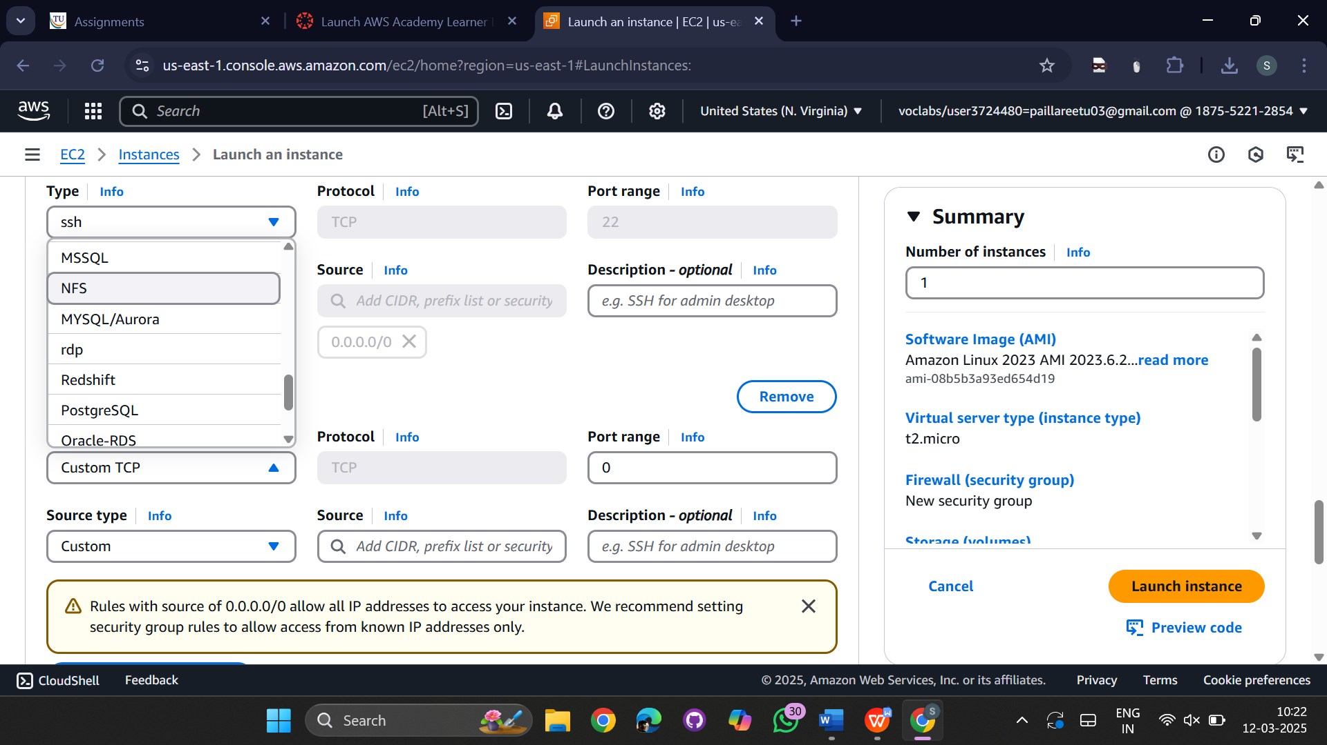

Select Source type->Anywhere

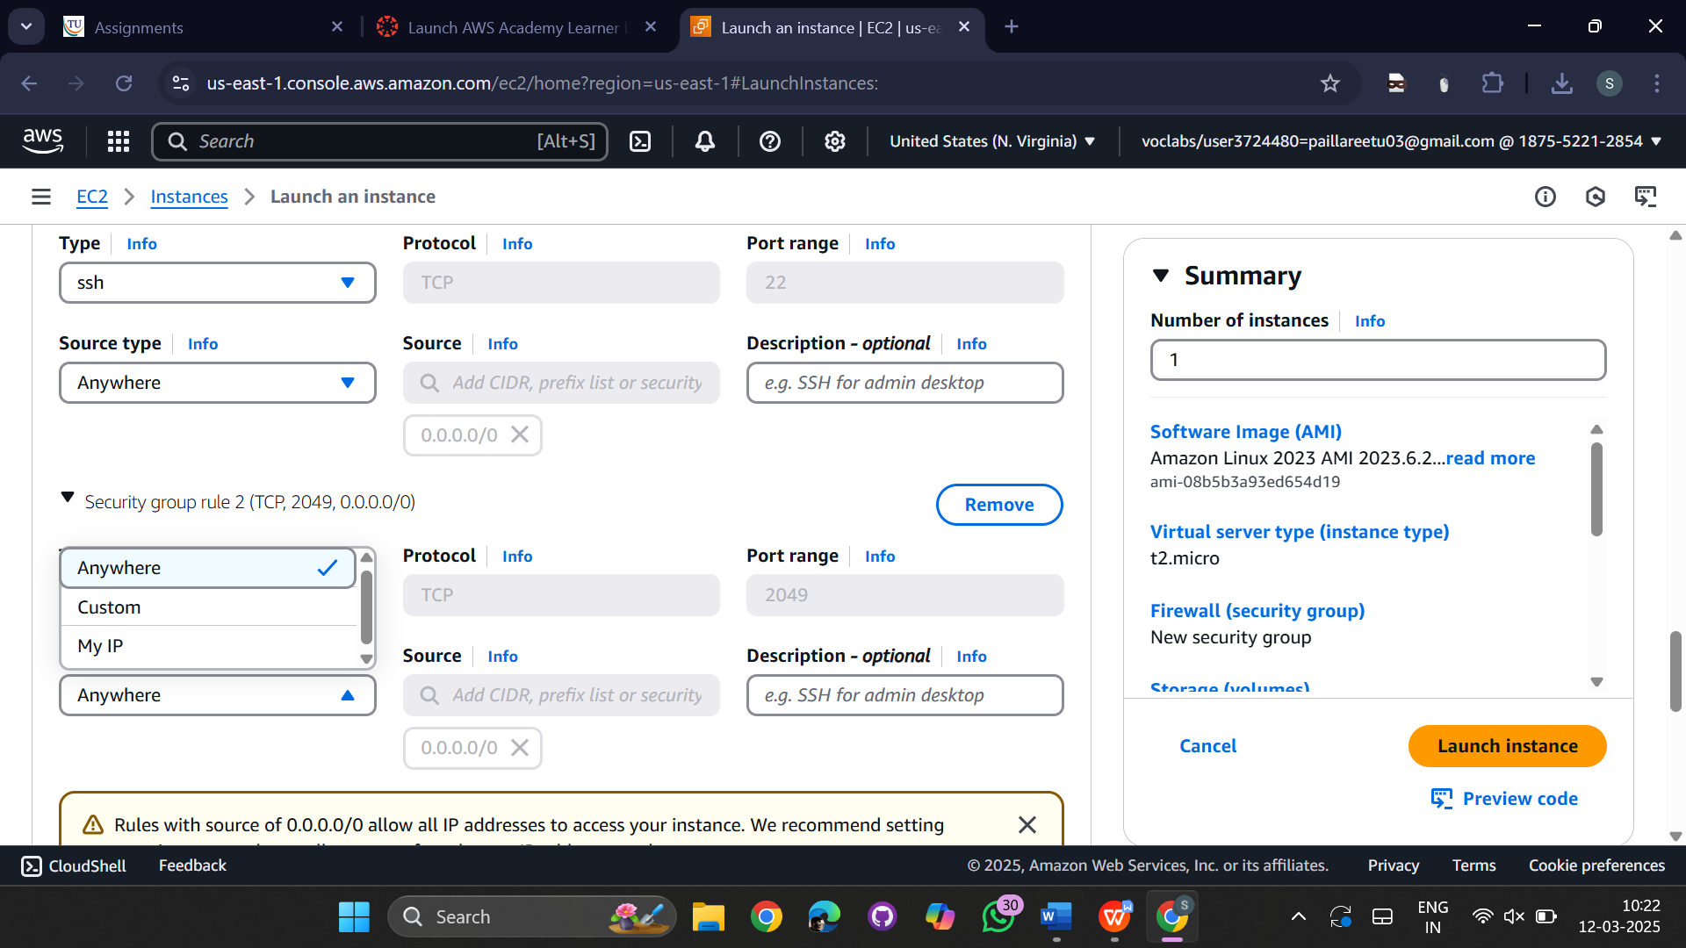

Create a new instance

selecting Amazon linux (AMI) and t2.micro as storage and CPU and create a new key pair

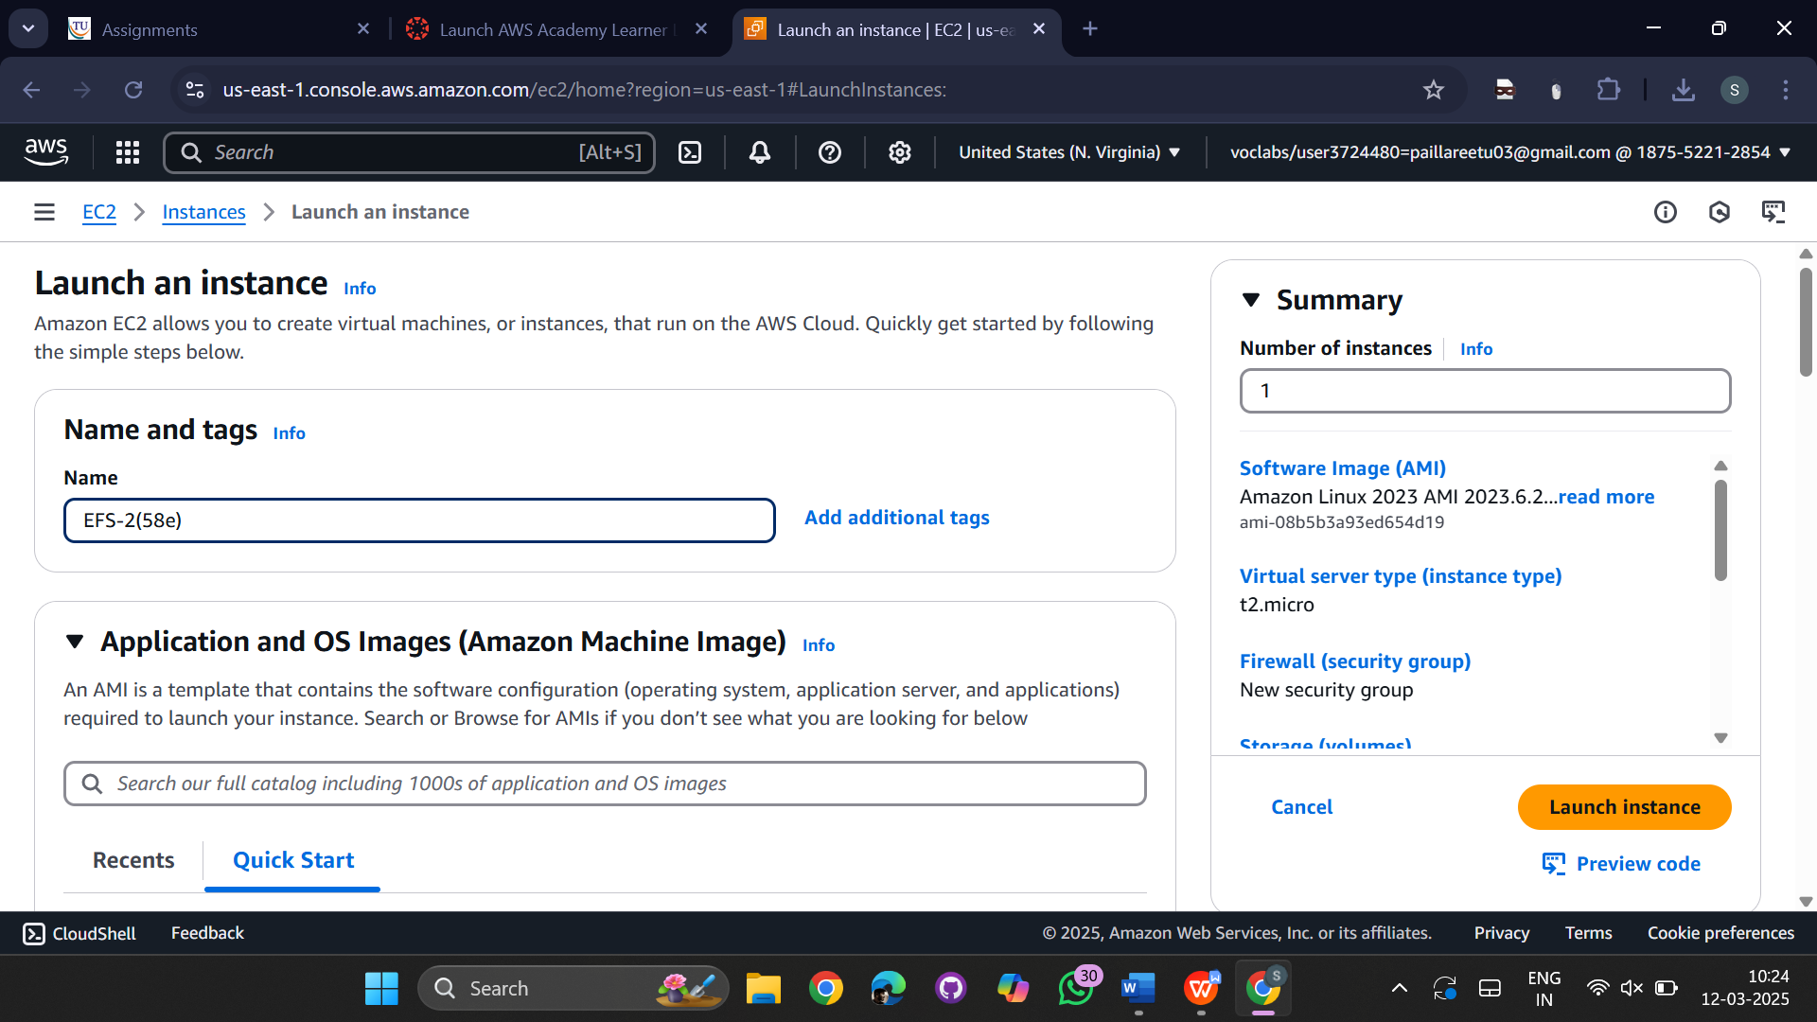

Create a new key pair .ppk

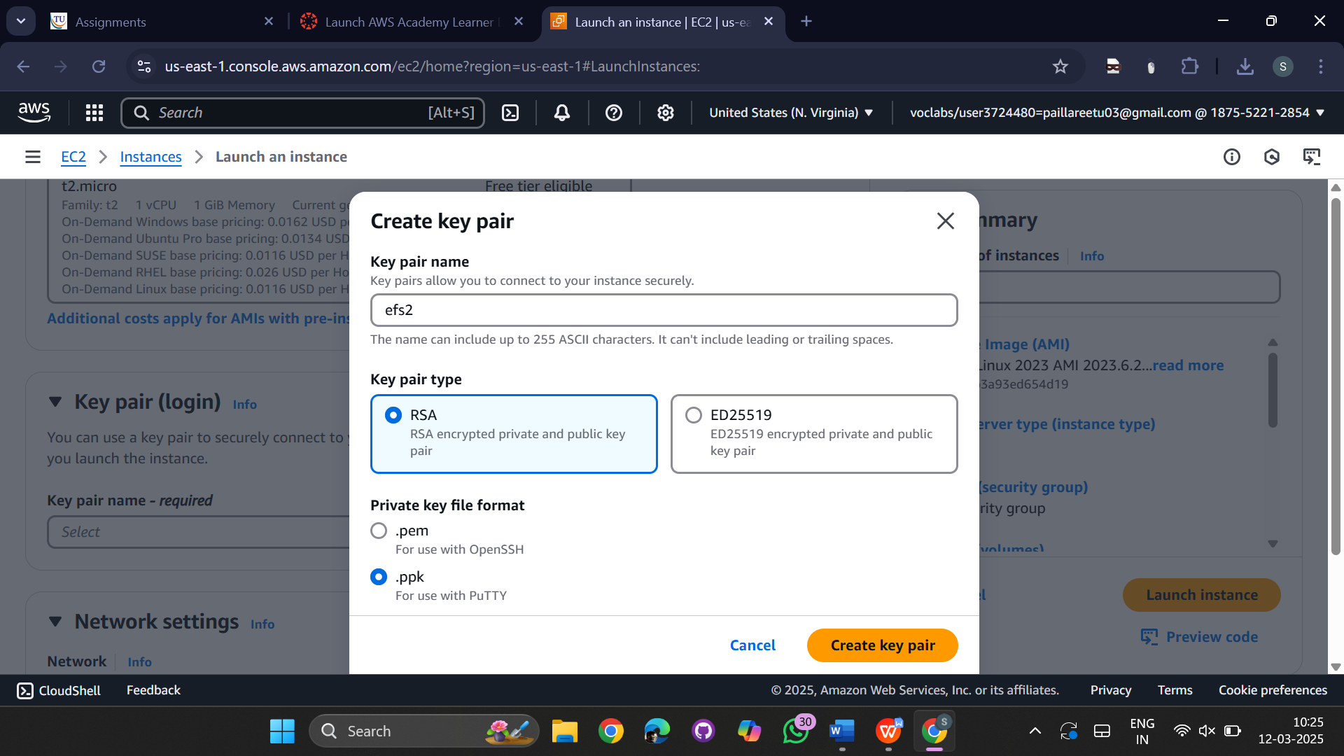

Go to Network settings->select subnet->us-east-1b

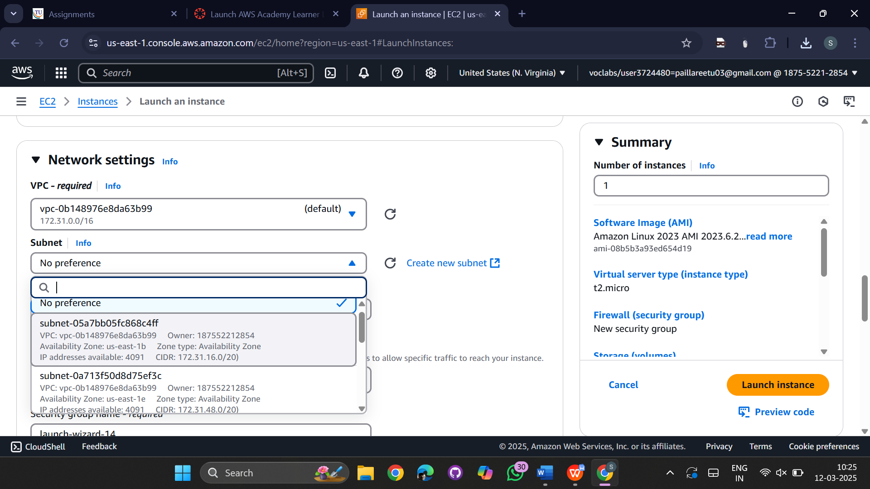

Firewall(security group)->select existing security group

Common security group->EFS-NFS

Launch the instance

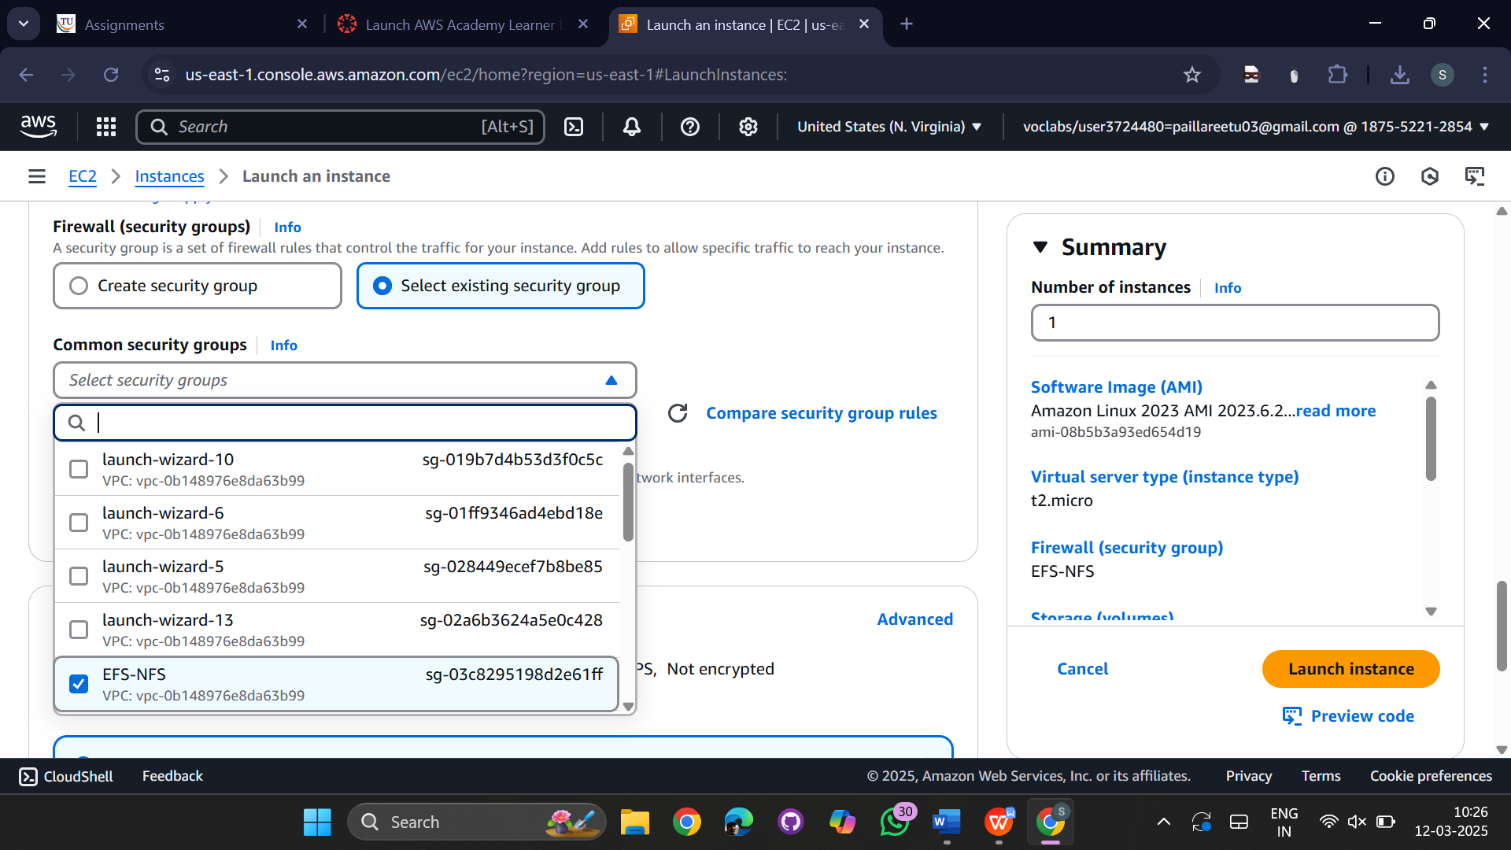

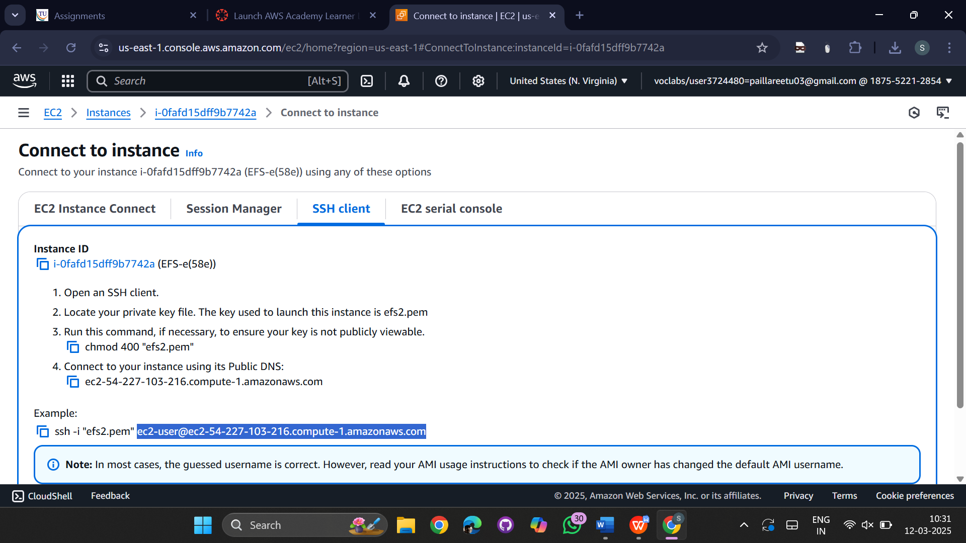

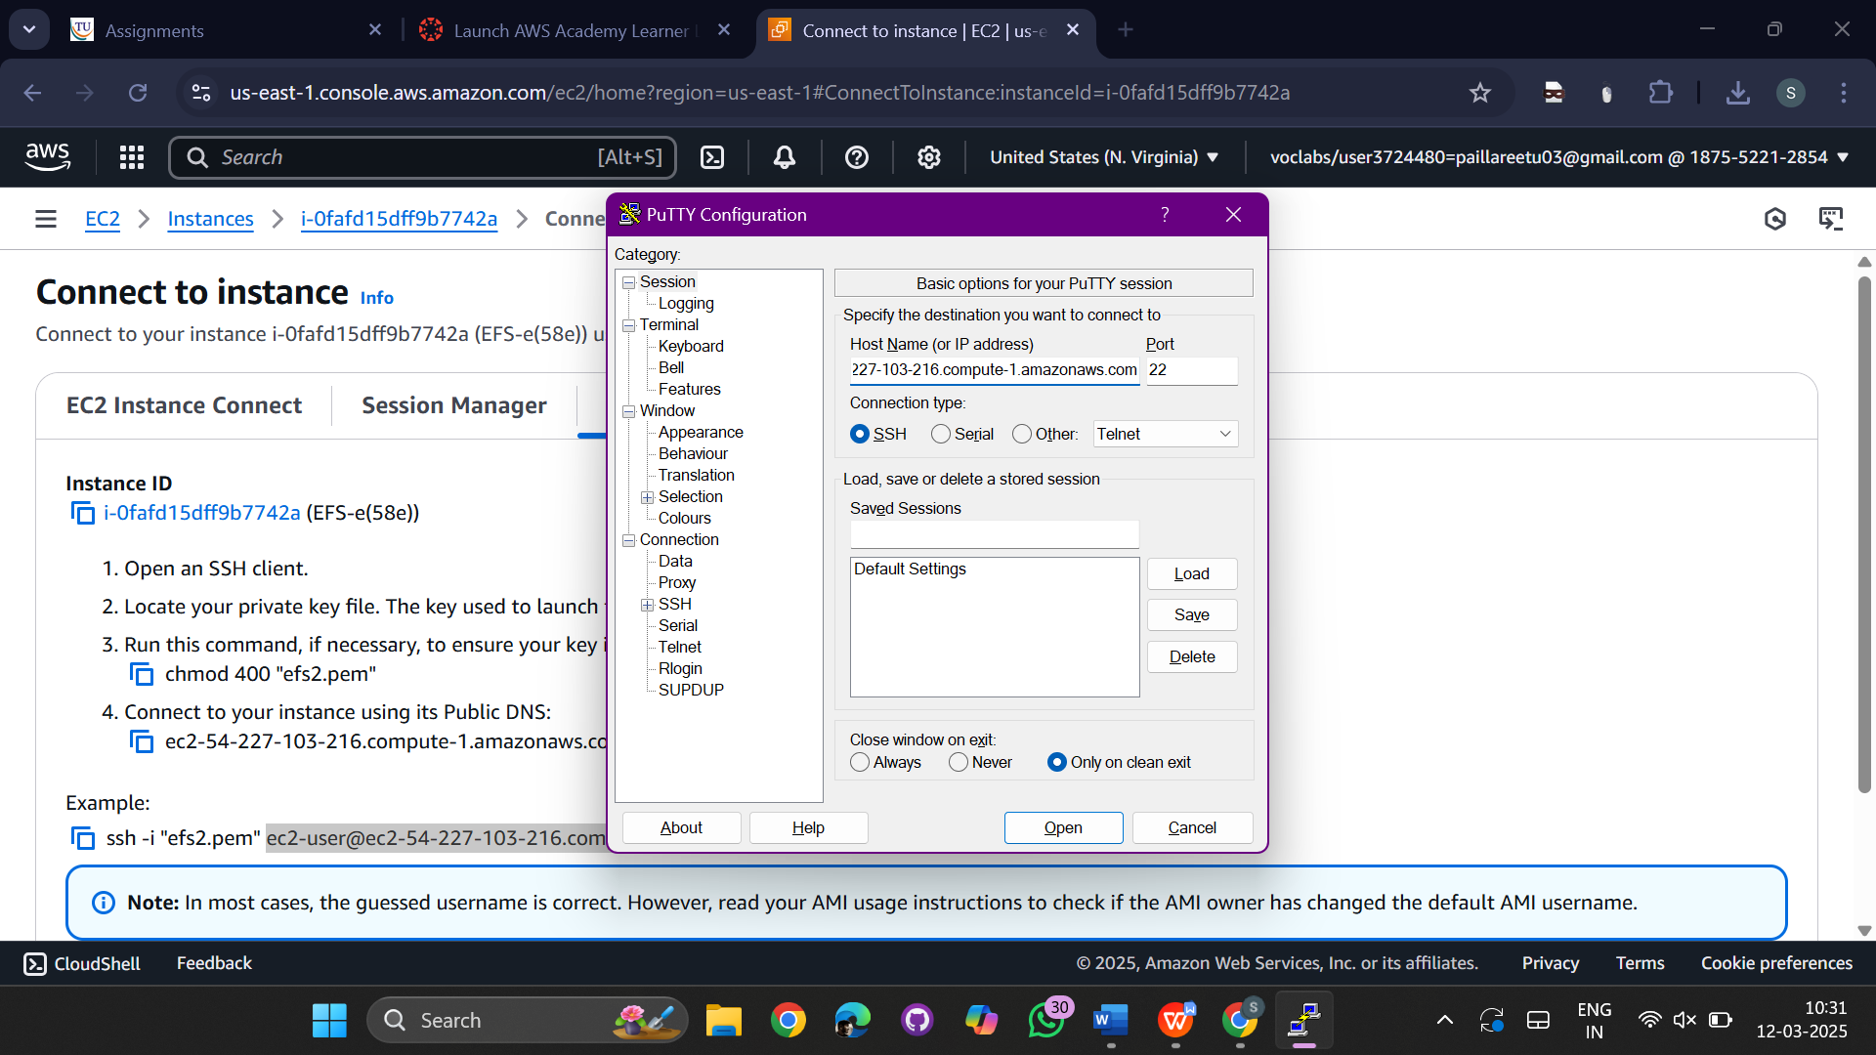

Go to SSH->Auth-> credentials

Browse the .ppk and select it

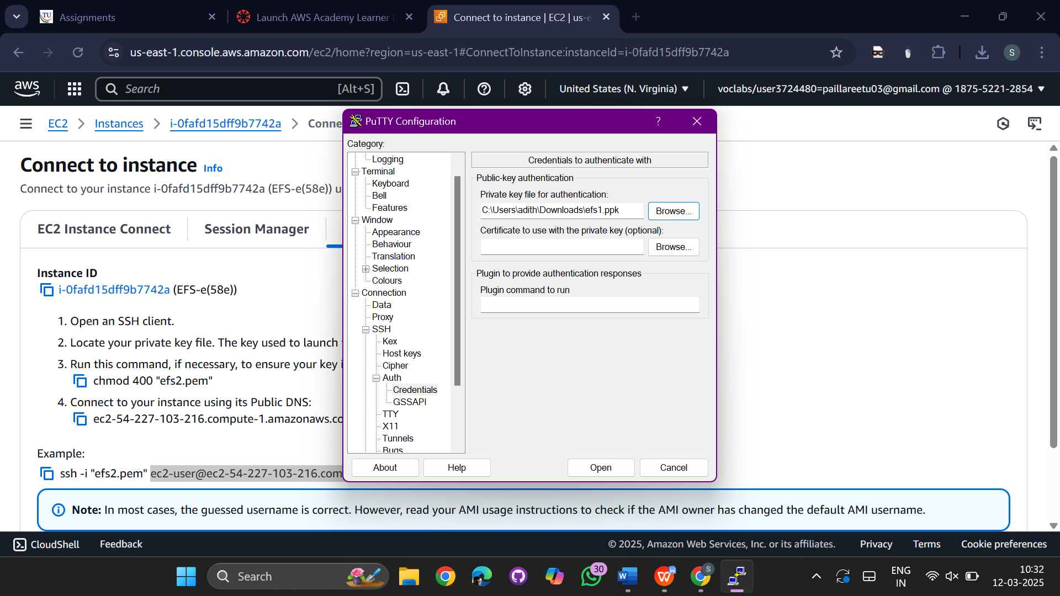

cmd will be opened

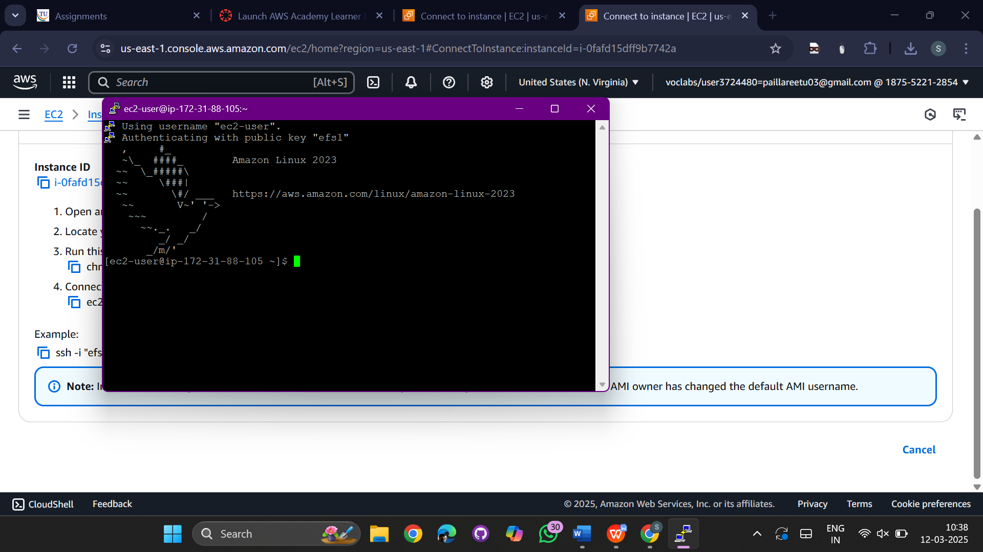

Same like above open connect to putty for efs2 instance also

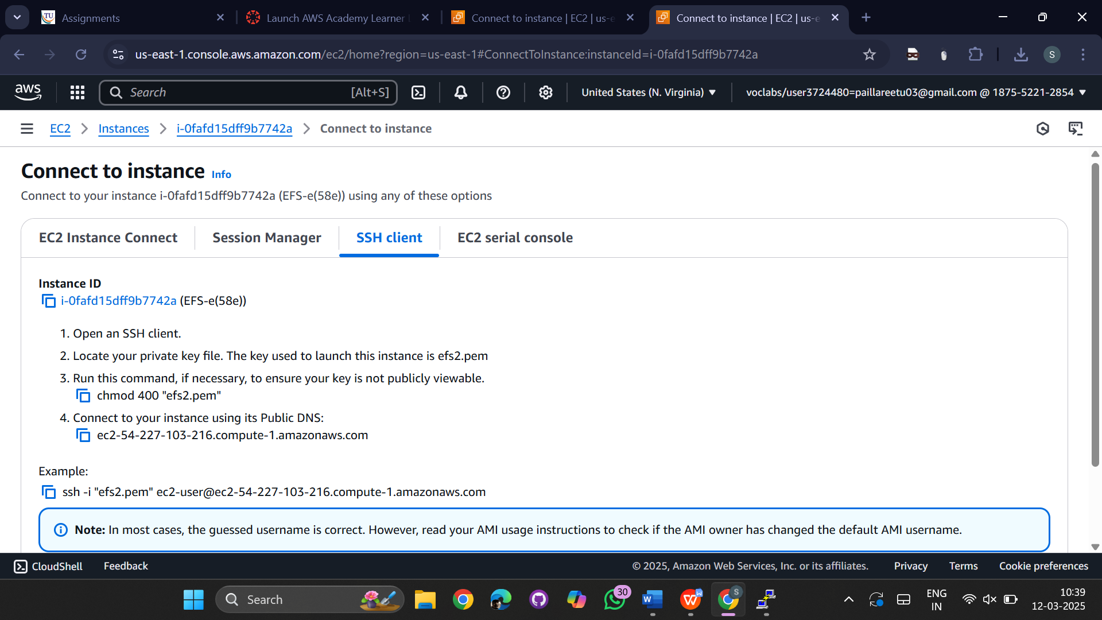

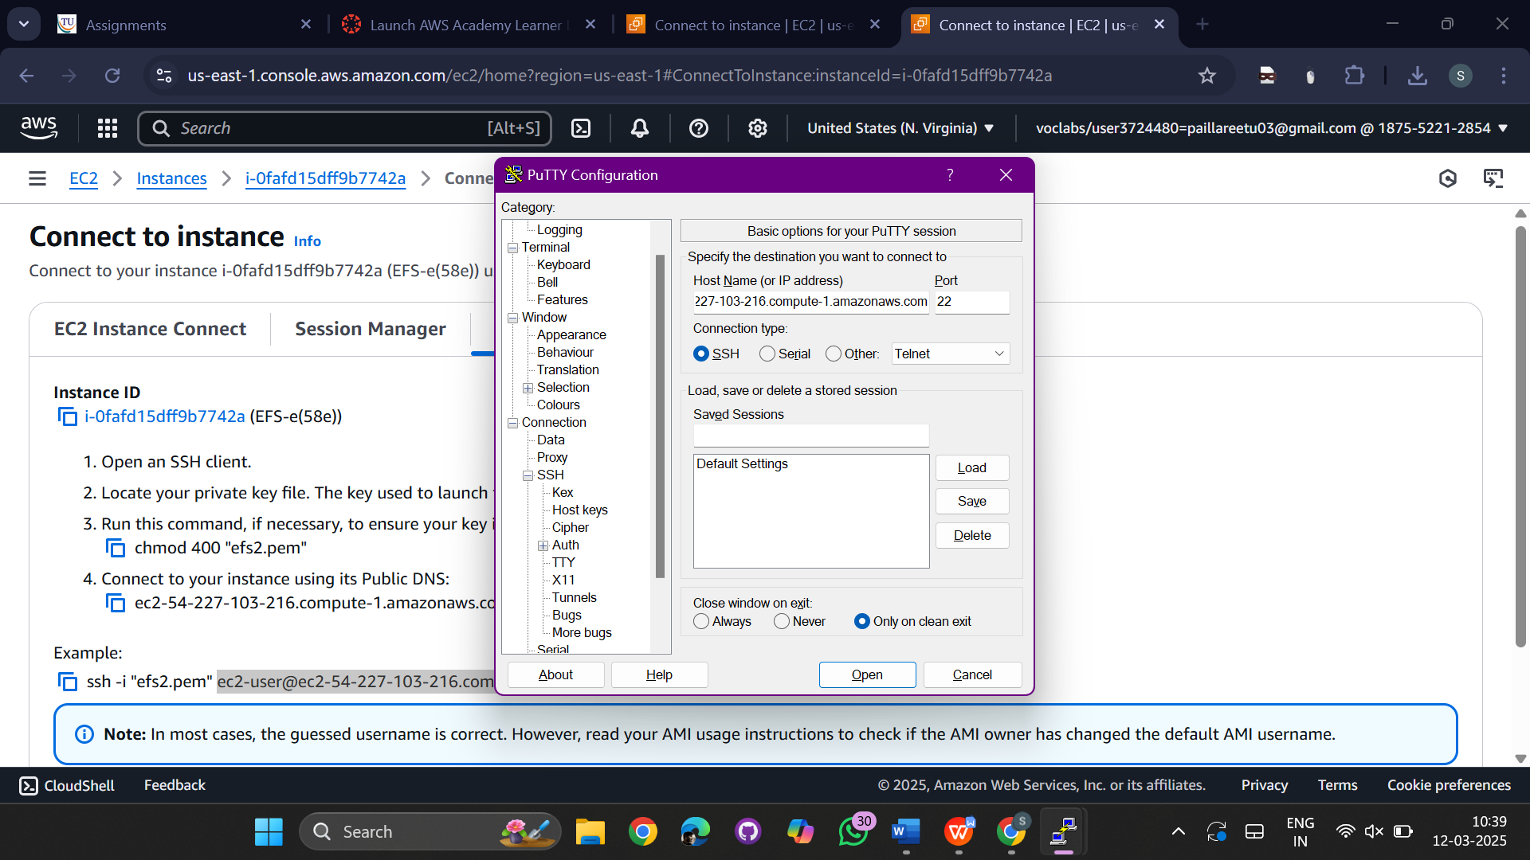

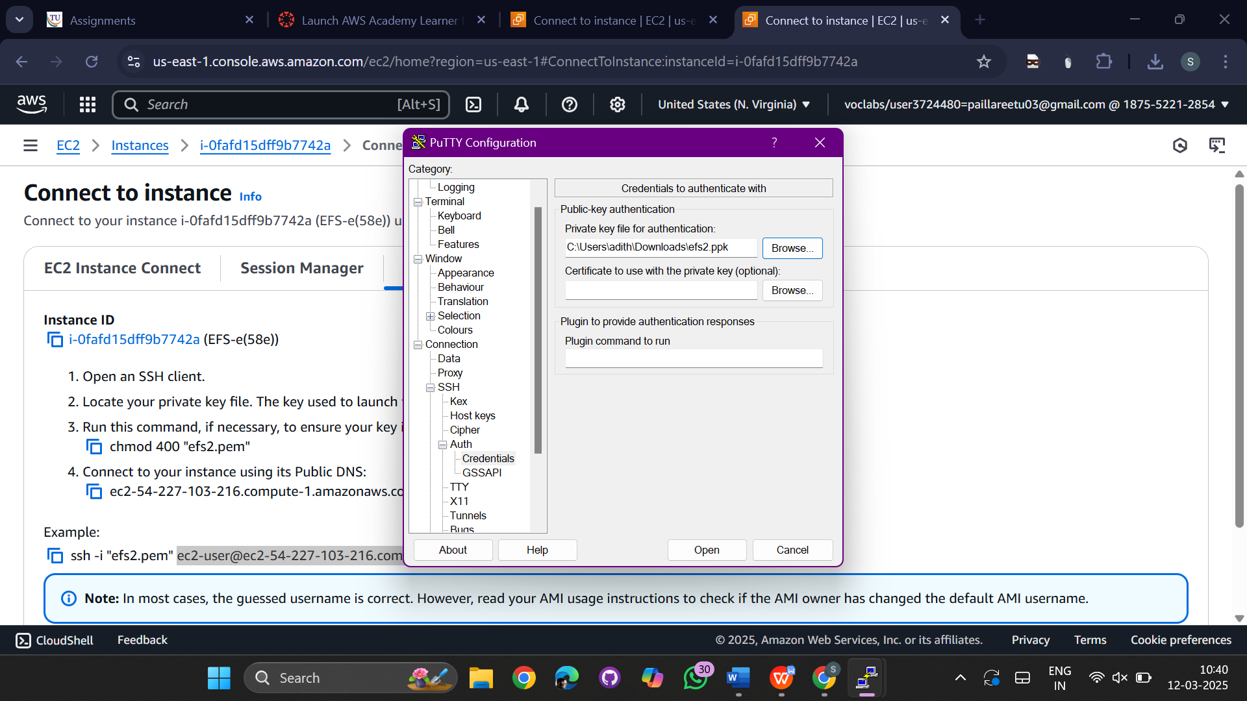

Open both the consoles and run the following commands  
sudo su

mkdir efs

yum install -y amazon-efs-utils

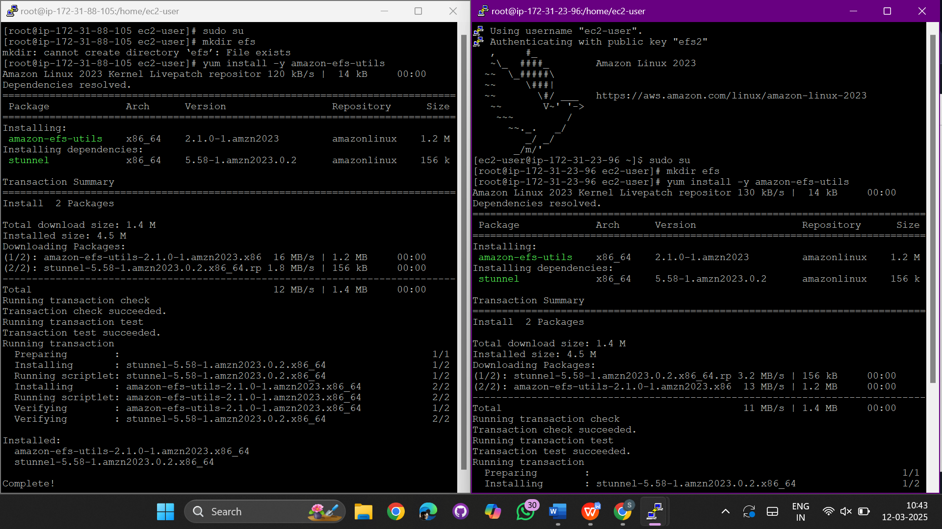

Got aws console

And click on all services

Select efs service

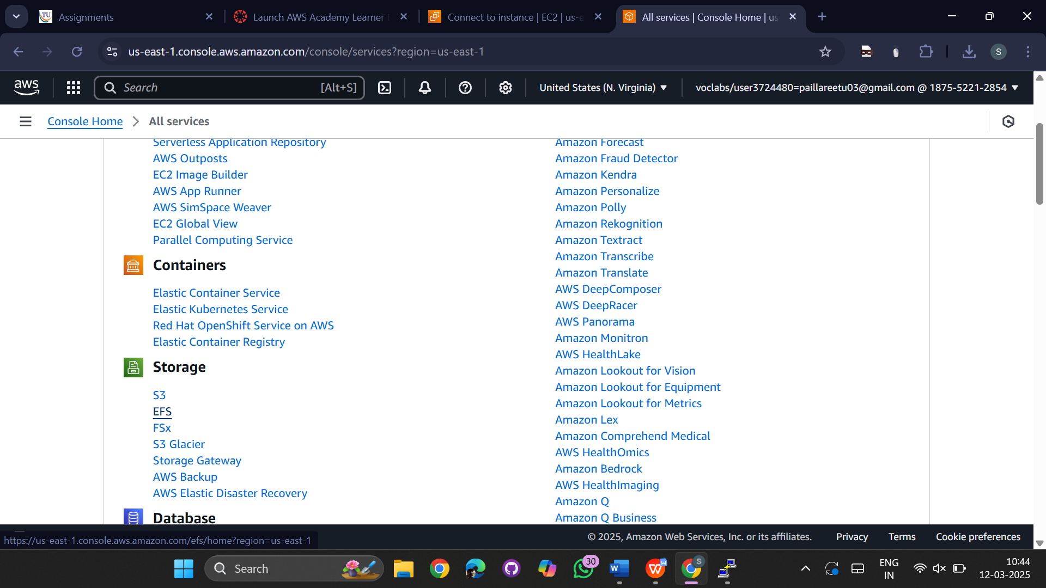

Click on create file system

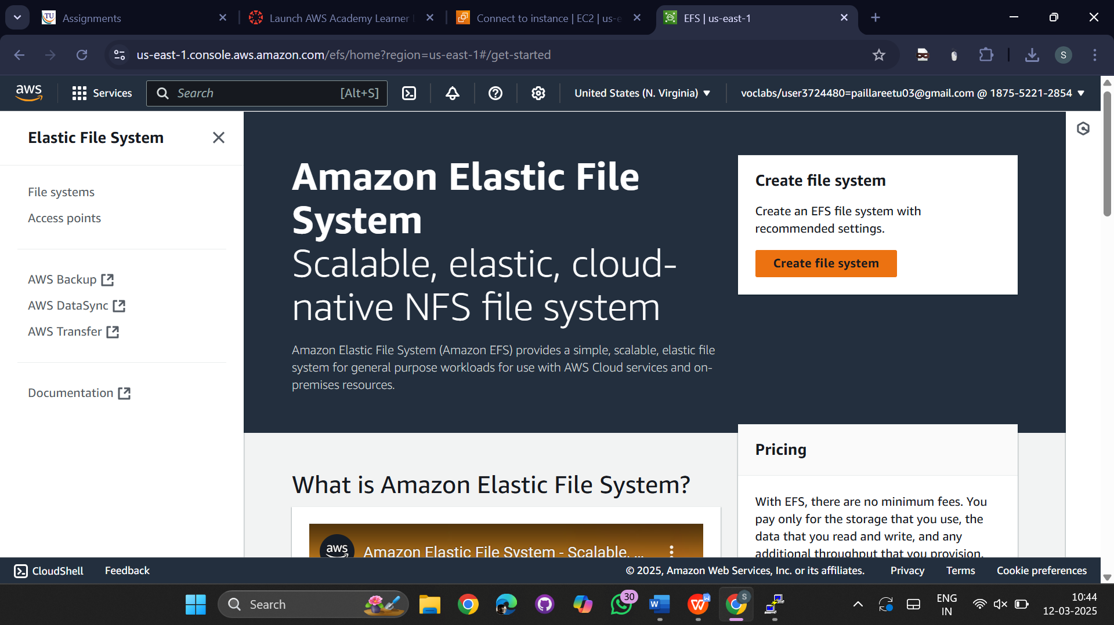

Give name for file and click on create

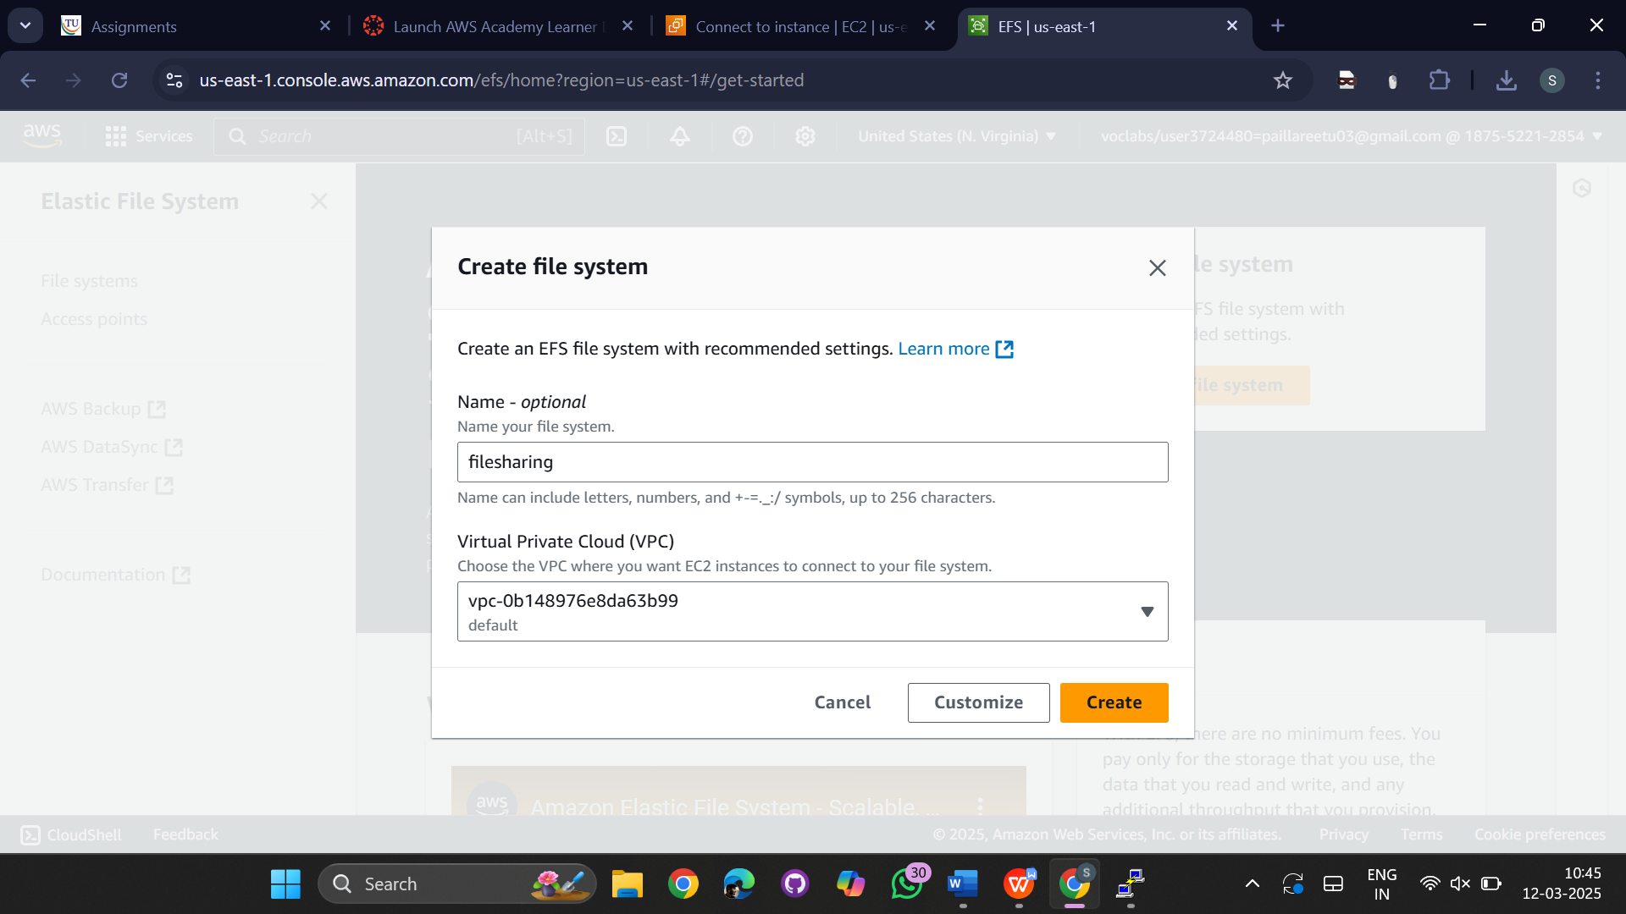

Click on the file ->view details

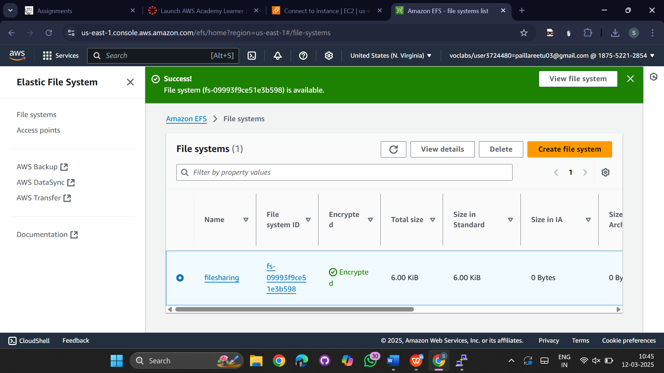

Go to Network

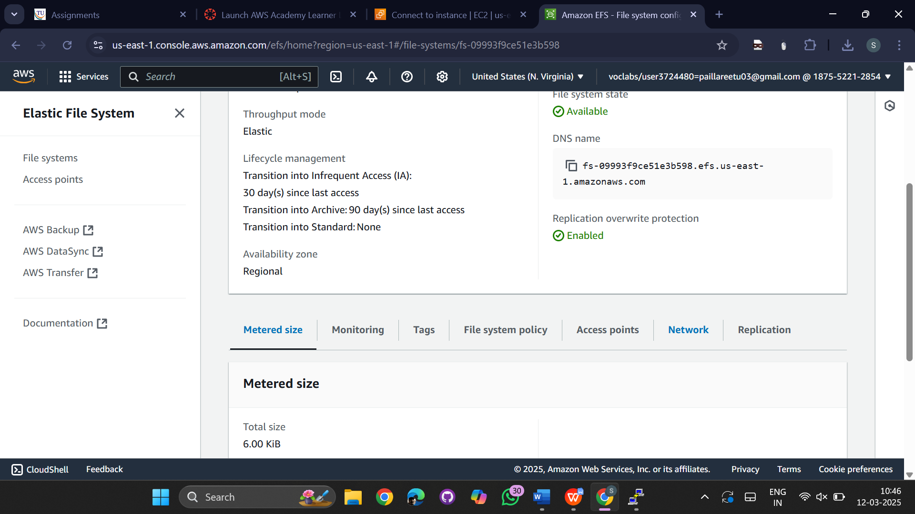

Click on manage

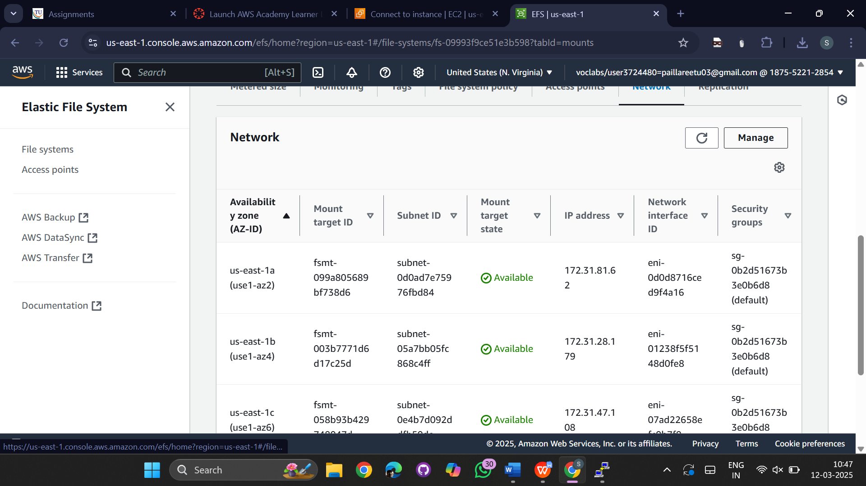

Give the security group of EFS-NFS for both us-east-1a and us-east-1b zones

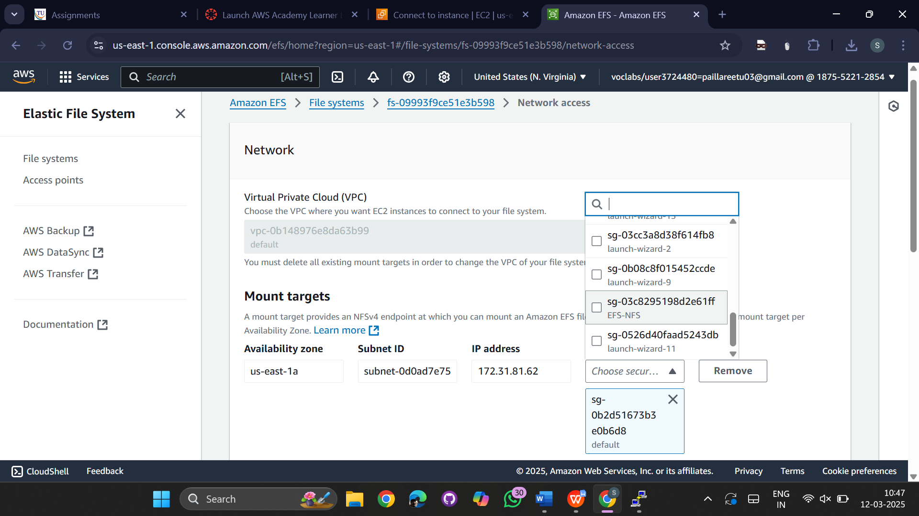

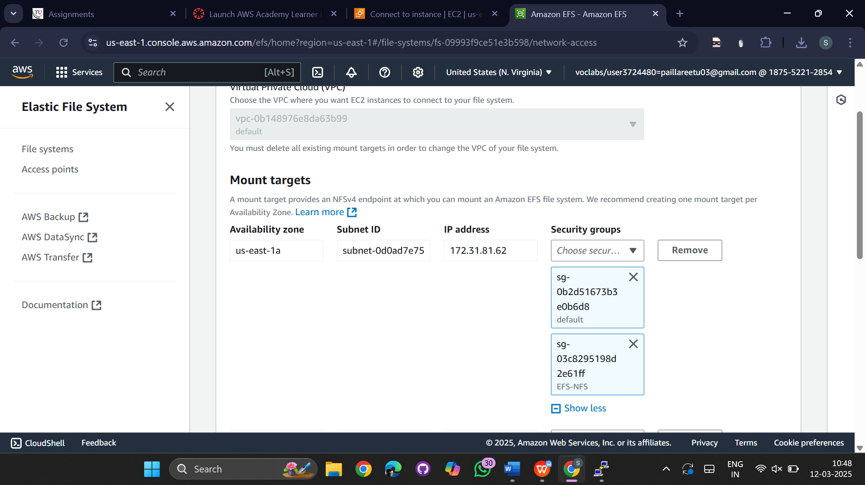

Now click on attach

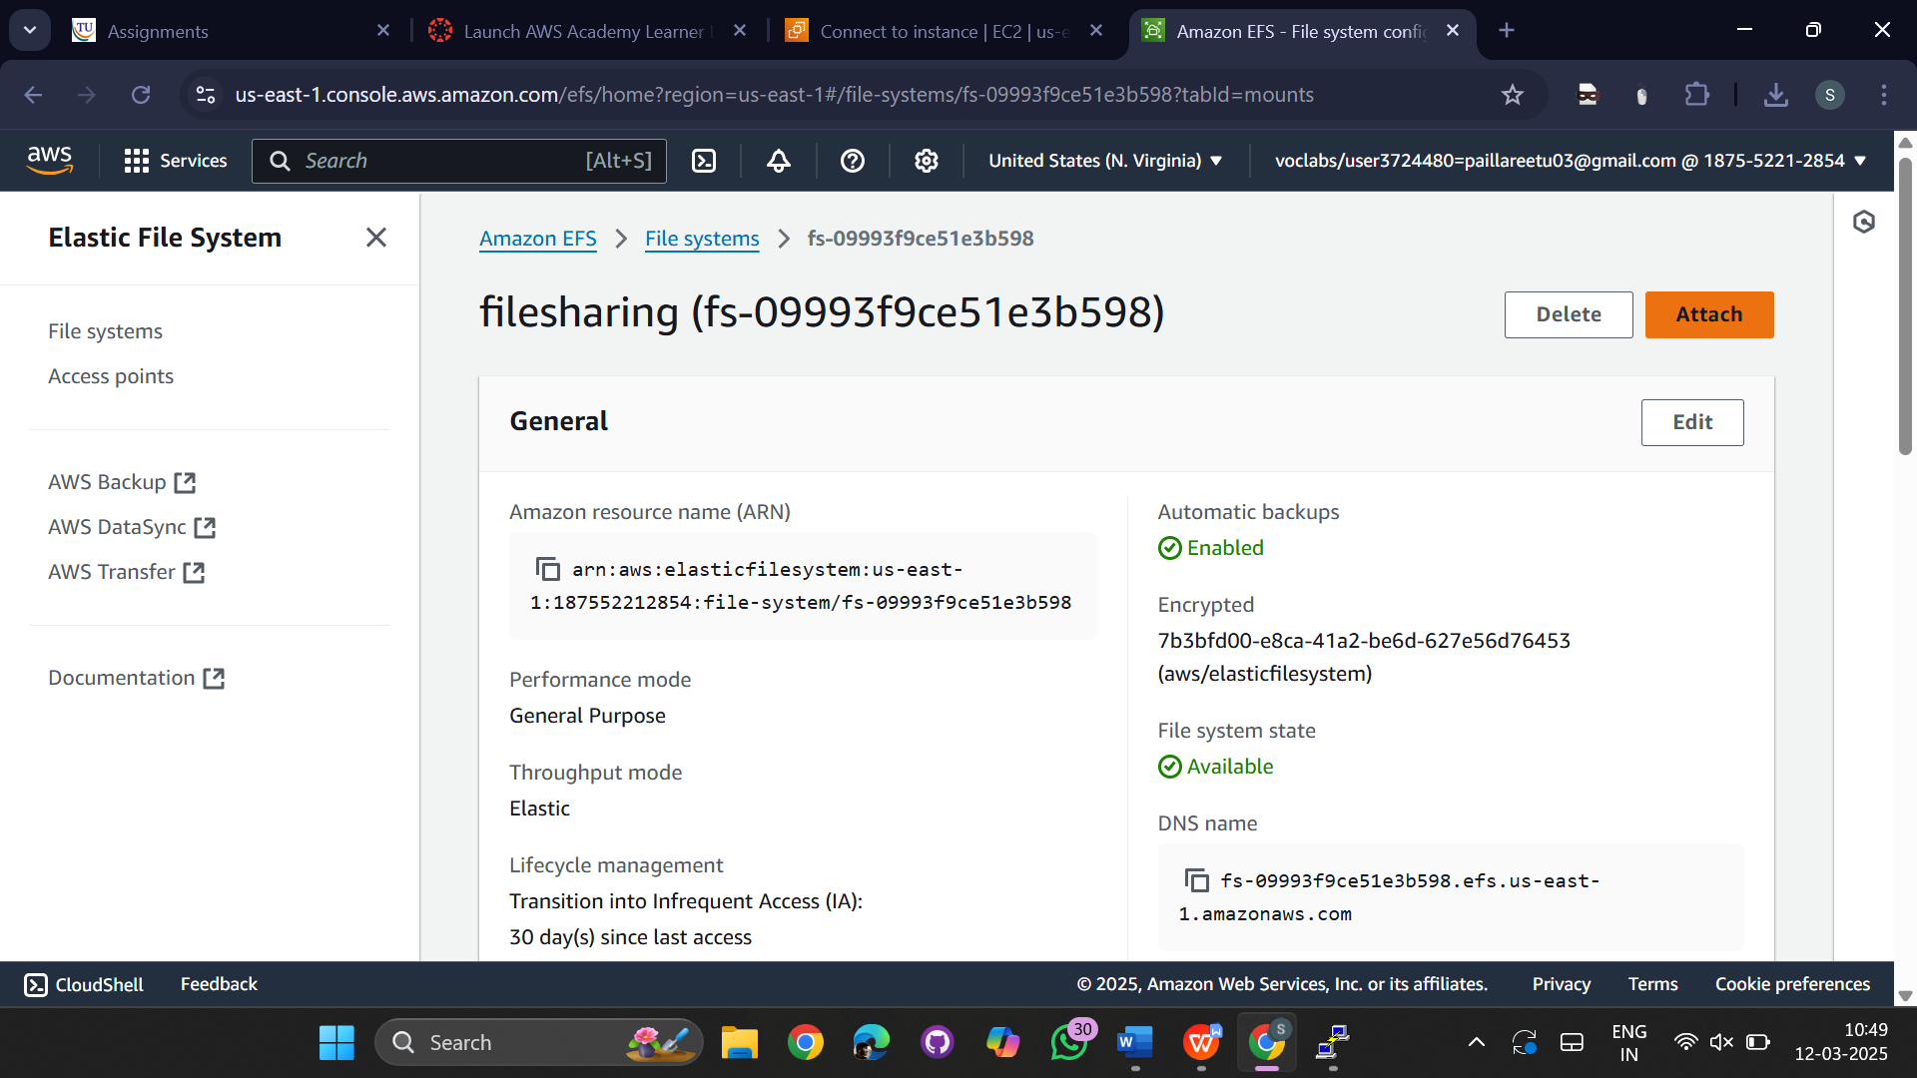

Copy the NFS client command

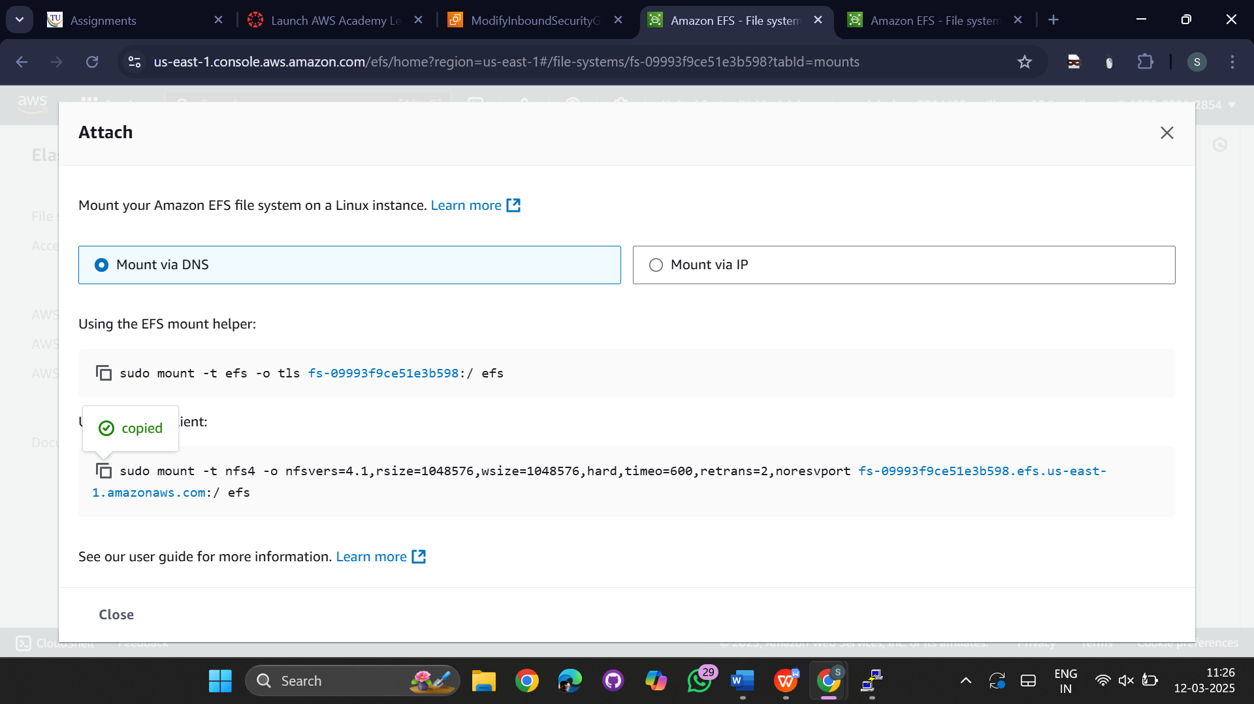

Paste and run the NFS client in both the connections terminals

Run commands for efs1-

Cd efs

Touch f1

Ls

Commands for efs2

Cd efs

Ls

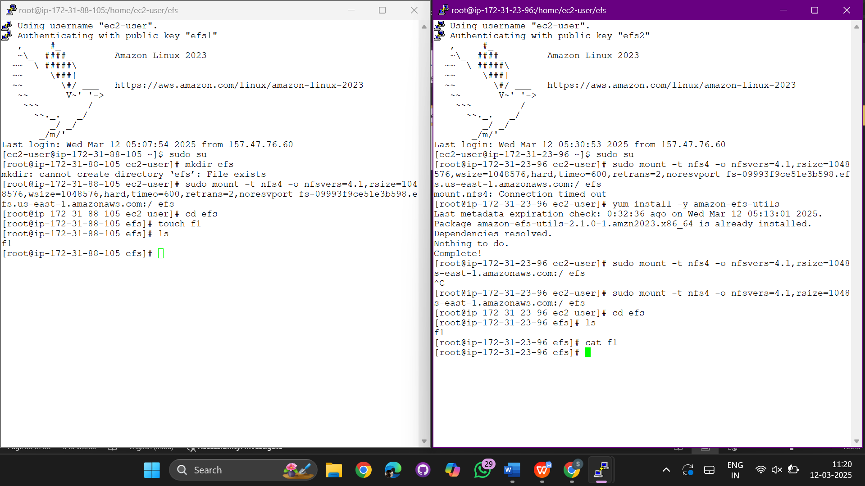

Run

yum install-y git in both the termnals

Now run the command in efs1

git clone <https://github.com/sathwikaDuduku/mavenJava.git>

in Efs 2

run ls

we can see the files of mavenjava the file is enable for other available zones

